Introduction To World Wide Web

In Sixties, computers usage became widespread in the USA. The United States military constructed a computer network called ARPANET, which was designed to connect important computers in the country. The specialty of this network was that there was no dedicated server. Each computer can communicate with other computers in the network, known as peer-to-peer model. The basic idea of this network was to resist the disruption of the key computers in the country against a possible nuclear attack. Slowly academic community was connected to it besides military. Soon it became primarily used for scientific research. Later this network was renamed as Internet because it linked up many local area and wide area networks. In the beginning days of Internet, public did not know even its existence. Only Universities were using it. In 1989 a computer scientist Tim Berners-Lee came up with the concept of World Wide Web. He developed an interactive hypertext system on the existing Internet.
Internet and WWW are not one and the same. The Internet is the physical computer network that links computers around the world. The WWW is a service that sits on the foundation of Internet. The web allows computers to communicate with each other. WWW is one of the many services offered by the Internet. For example, E-mail.
WWW as a service defines how a web client and a web server use the Internet to communicate. When we visit a website, a relationship is created between the web client (browser) and the web server. The web client sends a message to the web server requesting the particular web page that an end-user asked for, and the web server responds with an appropriate message that contains HTML for the page. A web browser making a request and the web server sending the response is known as request-response model. In this model, the requests and the responses travel over the web using Hyper Text Transfer Protocol. The request the web client sends is known as Http request and the response the web server sends back to the client is known as Http response.
Hypertext: - It refers to any system in which certain words or images function as links to other documents or other parts of the same document.
HTTP: -HTML is a language used to describe the contents of a web page. Hyper Text Transfer Protocol is the language used to describe how HTML documents are sent over the Internet. Understanding this protocol and the environment in which it operates is the key to web programming.
HTTP prescribes the rules by which browsers make requests and the servers supply responses. HTTP consists of a set of commands written as lines of text. When we type a URL or click a hyperlink, the browser translates our action into HTTP commands that request the document from the server specified in the URL. The web server program finds the document in the server machine’s file system and sends back to the browser.
Internet standards are specified in RFC (Request for Comments) published by the IETF (Internet Engineering Task Force). RFC2616 gave the HTTP/1.1 specification. This specification describes the HTTP as a connectionless or stateless protocol whose operation is as follows.
- Web browser opens a socket to the web server’s port.
- Through this connection the browser writes the request text line, zero or more headers and associated data.
- The web server parses the request and locates the specified resource.
- The server writes a copy of the resource to the client socket.
- The server closes the connection.
Types of web pages
Web pages are the means with which an end-user gets information from the website or give some input to the website. Web pages are developed as HTML documents (see for HTML basics in appendix-I). We have two kinds of web pages.
- static pages
- dynamic pages
If a website has only static web pages means that web site is only informative but not interactive. The order of the day is to provide interaction for the end-users. Static web pages are produced prior to any client request. Web designers develop them using web designing tools. Their content does not change with client requests. A server side program produces dynamic web pages. For example, a servlet or a jsp develops them and gives to the web server.
Java and Web
In the early days of Java, applets were the contribution of Java for WWW. Using applets, image animations and listening to music was made possible in the web pages. Currently In the Enterprise world, java is used at the server side to develop interactive online business applications, i.e. web applications that offer the customers online business services.

WEB APPLICATION DEVELOPMENT

We can broadly classify business applications into two areas. Windows based applications and web applications. Windows based applications are also known as desktop applications. For windows based applications the business organization staff only can be the end users. Customers should visit the business premises to get the business services. In Java, Swings is used as front-end for windows based applications. Capturing user data, contacting the database, processing the data and giving the response to the user interaction etc. should be implemented in the event handlers of the windows application. Such applications scope is limited. They cannot offer business services online to the customers.
Our advanced Java course is meant for web enabling the business applications. i.e. developing internet based business applications, famously known as online applications. For such web applications not only the business organization staff but also the customers can be the end users. Customers can get business services online 24X7.

Web Application architecture
Generally a web application will have a minimum of 3 layers/tiers.
- Client tier
- Presentation tier
- Data tier
Client tier presentation tier data tier
HHTMTML

Web browser web server
Database
Browser is the client tier. In the browser HTML document is executed and the web page is displayed to the end user. Client tier acts as an interface between the end user and the web application. HTML forms act as the GUI (Graphical User Interface) for the end users. With a web application, end user’s interaction and getting the response is through web pages only.
Web server process (In Java, web container) is the presentation tier. Servlets, jsps and Java beans run in this tier. This tier presents the output to the client after processing the client request and hence the name. Enterprise data is stored in the data tier. Mostly RDBMS is the data tier. Presentation tier contacts the data tier to store, modify or retrieve data. Servlets, jsps and Java Beans in the presentation tier make use of JDBC to communicate with the database.

SERVLETS
Introduction:
In the early days of Internet, websites have only static web pages. I.e. web pages were only informative but not interactive. Introduction of CGI gave life to the static World Wide Web. In combination with the HTML forms CGI provided a mechanism for true two-way communication between the browser and the web server. This new technology paved the way for interactive web applications like online shopping, online bill payment, online banking etc. As industry embraced WWW as the place of global business, CGI was showing signs of aging in terms of performance and flexibility. Emergence of new technologies became inevitable to replace CGI as the standard interface for building dynamic websites. SERVLETS & JSP are such web technologies from Sun. Servlets replace CGI programs in the context of a dynamic website.
A servlet is a server side web component written in java that extends the functionality of a web server.
Servlets are superior to CGI programs
A CGI program dynamically builds and returns an HTML page to the client based upon the user input. It processes the user input and stores it into the database. It retrieves the data from the database that is required for the end user. For a website to offer online business services this functionality is mandatory. Servlets, as a replacement for CGI programs, provide the same functionality with increased performance, portability and security.
For each client request, CGI based server creates a new process and the process is destroyed as soon as the response is given to the client. Since a new process must be created for each request, database-driven pages require a new database connection with every request. It incurs a high performance penalty. In contrast, a servlet shares a single database connection across multiple client requests. More over, a single process attends multiple client requests by creating multiple threads. Unlike CGI applications, servlets can run on different servers and platforms without modifications. Servlets being written in Java offer much better security when compared to CGI.

Servlet API:
To develop servlets we need SERVLET API support. We have 2 packages for developing servlets.
- javax.servlet
- javax.servlet.http
Servlet: - This interface provides life cycle methods for our servlets. The life cycle methods are
- init(ServletConfig)
- service(ServletRequest, ServletResponse)
- destroy()
In our servlet class we override these methods. Servlet engine calls these methods implicitly. Servlet interface has 2 more methods, which are non-life cycle methods.
- getServletConfig():- It returns ServletConfig object
- getServletInfo():- It returns a string that gives servlet information.
GenericServlet: - This is an abstract class. This class implements Servlet interface. It defined init(ServletConfig) and destroy() methods of the Servlet interface. The third life cycle method service() is not defined in the GenericServlet class. This class also implements ServletConfig interface. Therefore all the methods of ServletConfig interface can be called directly on the servlet instance itself. It is a flexibility given to the servlet developers. GenericServlet class defines one zero argument init method also. The servlet engine does not call this zero argument init method. Parameterized init method defined by the GenericServlet calls this zero argument init method. Therefore servlet developers can override only zero argument method in their servlet classes.
HttpServlet: - This is an abstract class. It is a sub class of GenericServlet class. Servlet developers always define their servlet class by extending this class. Service method of the GenericServlet is implemented in this class. In addition to this public service method, the HttpServlet class has defined the following important methods.
- protected void service(HttpServletRequest, HttpServletResponse)
- protected void doGet(HttpServletRequest, HttpServletResponse)
- protected void doPost(HttpServletRequest, HttpServletResponse)
Servlet engine calls only public service method. Within the public service method protected service method is called. Within the protected service method of the HttpServlet class, either doGet() or doPost() method is called depending upon the type of request(GET or POST) coming from the client. In our servlet class we always override either doGet() or doPost(). We never override public service() or protected service().
ServletConfig: - It is an interface. Servlet engine writes one sub class for this interface and creates the object of that class. But we say it is a ServletConfig object. It provides the following 2 important methods.
- String getInitParameter(String): This method is used to get the init param value by supplying param name as input.
- ServletContext getServletContext(): When we call this method, it returns the ServletContext object.
Note: - Actually these methods are to be called on “config” object. As GenericServlet implements ServletConfig interface we can call these methods directly on our servlet instance without using config object.
ServletConfig interface has 2 more methods. We use them rarely.
- Enumeration getInitParamNames(): It returns all the init param names
- String getServletName(): This method returns the servlet registration name.

ServletContext: - It is an interface. Servlet engine writes one sub class for this interface and creates the object of that class. But we say it is a ServletContext object. In servlet programming this object is very widely used. For a servlet this object is not directly available. We should call a method in a servlet to get the ServletContext object.
ServletContext sc=getServletContext();
In the above statement we are calling getServletContext() on the servlet instance. But internally it is called on the ServletConfig object. ServletContext interface has the following important methods.

- getInitParameter(): Takes context param name and returns correspoding value.
- setAttribute(): - stores a data item in context scope with name, value pair.
- getAttribute(): - takes the attribute name and returns the value.
- removeAttribute(): - Deletes a data item from context scope.
- getRequestDispatcher(): This method returns RequestDispatcher object
- getServerInfo() : this method returns the web container information as string
- log(): This method is used to store information into web container log files.

HttpServletRequest: - This is an interface in javax.servlet.http package. It is a sub interface of ServletRequest interface. In our servlets we don’t directly use ServletRequest interface. Servlet engine writes a sub class of HttpServletRequest interface and creates its instance. But we call it HttpServletRequest object only. The following are the important methods of HttpServletRequest (some are inherited from ServletRequest).
- getParameter():- Takes HTML control name and returns the user input value.
- setAttribute() :- stores a data item in request scope with name, value pair.
- getAttribute(): - takes the attribute name and returns the value.
- removeAttribute(): - Deletes a data item from request scope.
- getRequestDispatcher(): This method returns RequestDispatcher object
- getCookies(): - It returns an array of Cookies coming from the browser.
- getSession(): - Returns the HttpSession object which is unique for the client.
- getQueryString(): - Returns the query string that is contained in the request URL after the path.
- getHeaderNames(): - Returns an enumeration of all the header names this request contains.
- getHeader(): - It takes the header name and returns the header value.

HttpServletResponse: - This is an interface in javax.servlet.http package. It is a sub interface of ServletResponse interface. In our servlets we don’t directly use ServletResponse interface. Servlet engine writes a sub class of HttpServletResponse interface and creates its instance. But we call it HttpServletResponse object only. The following are the important methods of HttpServletResponse (some are inherited from ServletResponse).
- getWriter(): - It returns the PrintWriter object.
- setContentType(): - This method set the MIME type for the response
- getOutputStream(): - Returns the OutputStream object.
- addCookie(): - It adds a cookie to the response header.
- encodeURL(): - This method is used in URL rewriting
- sendRedirect(): - Sends a temporary redirect response to the client.
- sendError(): - Sends an error response to the client using the error status.
- setHeader(): - Sets a response header with the given name and value.
- addHeader(): - Adds a response header with the given name and value.
RequestDispatcher: - It is an interface. Servlet container writes a sub class for this interface. Servlet engine produces this sub class object when we call getRequestDispatcher() on the request object or context object. But we say that object as RequestDispatcher object only. This interface has 2 methods.
- forward():-It forwards the control from the servlet to another web resource.
- include(): - It includes the response of other web resource into the current servlet response.
HttpSession: - It is an interface. Servlet container writes a sub class for this interface. Servlet engine produces the sub class object when we call getSession() on the request object. HttpSession has the following important methods.
- setAttribute() :- stores a data item in session scope with name, value pair.
- getAttribute(): - takes the attribute name and returns the value.
- removeAttribute(): - Deletes a data item from session scope.
- invalidate(): - destroys the session object
- setMaxInactiveInterval(): - specifies session time out in seconds.
- getId(): - returns the session id.
- getCreationTime(): - Returns the time when this session was created, measured in milliseconds since midnight January 1, 1970.
- isNew():- Returns true if it is a new session. False otherwise.
Cookie: - It is a class. We instantiate this class to create a cookie. This class has the following frequently used important methods
- getName(): - Returns the name of the cookie.
- getValue(): - Returns the value of the cookie.
- setMaxAge(): - makes a cookie persistent
- setDomain(): - Specifies the domain in which this cookie should be presented.
Filter: - This is an interface. Our own filter class implements this interface. This interface has 3 life cycle methods.
- init(FilterConfig)
- destroy()
- doFilter(ServletRequest,ServletResponse,FilterChain)
FilterConfig: - This interface is similar to ServletConfig interface. Servlet engine creates this object(sub class object). Most frequently used method of this interface is
- getInitParameter(): - Returns the param value by taking param name.
FilterChain:- This interface has only one method.
1. doFilter(): - switches the control from one filter to other filter or to a servlet.

General structure of a servlet
import javax.servlet.*;
import javax.servlet.http.*;
import java.io.*;
public class OurServlet extends HttpServlet
{
public void init() throws ServletException
{
/*
Retrieving initialization parameters.
Providing resources to the servlet like database connection.
*/
}
public void destroy()
{
//Releasing resources like closing the database connection.
}
public void doGet/doPost(HttpServletRequest request,
HttpServletResponse response) throws ServletException,IOException
{
//Client request processing code.
}
}
Servlet engine loads this class into memory, creates its instance and calls init method and doGet/doPost methods implicitly. When the servlet is unloaded, the servlet engine calls the destroy() method.
Web container offers the following support.
- Servlet life cycle management
- Concurrency support.
- Communication support.
When multiple concurrent requests come to the web container it implements multithreading. This is nothing but concurrency support. A servlet does not need to talk to the clients to get user data. Web container provides that support.
Servlet Life cycle:
Servlets are container managed. The life and death of servlets is under the control of the Servlet Engine. Servlet engine is developed strictly according to the SERVLET specification. Our servlet also is written conforming the same specification and by following the SERVLET API. Therefore the servlet container can manage the servlet life cycle. The servlet life cycle steps describe the process by which the servlet container loads, instantiates, unloads and invokes its life cycle methods.
- The servlet container loads the servlet class that we developed and deployed into it. This can happen either at the time of web application start up or on receiving the client request for the first time.
- The servlet engine creates the servlet instance.
- Servlet engine creates the ServletConfig object.
- Servlet engine calls the init method by supplying ServletConfig object as argument (Parameterized init method internally calls the zero argument init method).
- Servlet engine creates ServletRequest object & ServletResponse objects.
- Servlet engine calls the public service method and supplies the above two objects as arguments.
- Within the public service method these two objects are converted into Http specific objects and public service method calls protected service method.
- Within the protected service method client request type is calibrated (GET or POST). Depending upon the type of request, protected service method calls either doGet () or doPost(). In one of these methods a servlet developer implements the client request processing code that involves
  - Evaluating the HttpServletRequest object and capture the user input.
  - Producing dynamic data by communicating with the database.
  - Building dynamic web content and sending it to the client using HttpServletResponse object.

- If the container receives another client request, process starts from step 5.
- When the container is instructed to keep the servlet out of service (undeployed), the servlet engine calls the destroy method on the servlet instance just before the servlet instance is garbage collected.
Web application Development steps:
A servlet is a part of a web application. Therefore, to write our first servlet and execute it we need to know how to develop and deploy our web application.
Step 1: Create a directory structure according to SERVLET specification.
Root directory
WEB-INF
classes
lib
Root directory name can be any thing. It should have a sub directory “WEB-INF”. Within this two more sub directories classes & lib.
Step 2: Web resources development.
A web application contains HTML documents, image files, jsps, servlets etc. We have to develop all these resources as per our application requirement.
Step 3: Deployment Descriptor Development
Deployment descriptor is an xml file. According to SERVLET specification, each web application should have one deployment descriptor whose name should be web.xml. Typical actions we perform in the DD file are
- Registering the servlets.
- Creating the URL mappings for servlets
- Supplying initialization parameters
- Configuring the filters
- Specifying the listeners
- Specifying the error pages.
- Configuring the welcome files
- Configuring the session time outs.
- Registering the JSP tag libraries
- Configuring the security constraints etc.
Step 4: Deploying the web resources & DD file into the web application
In this step, we copy different files of the web application into the different directories.
- All the html documents, jsps and image files directly under the root directory.
- web.xml into WEB-INF
- All the java class files into classes directory
- All jar files into lib directory
Tomcat & web application deployment
For developing and deploying web applications we need web container software loaded into our computer system. Tomcat is a web container from Apache Software Foundation. Once we install Tomcat, it will be installed into an installation directory Tomcat 5.0. This is known as CATALINA_HOME. This installation directory will have few sub directories.
webapps: - Into this directory we have to copy our web application root directory.
bin: - In this directory we have Tomcat server start up & shut down MS-DOS batch files. By clicking on them either we can start up Tomcat or shut down it.
Common: - In this directory we have another sub directory “lib”. In this sub directory we have 2 jar files.
- servlet-api.jar
- jsp-api.jar
We have to set the class path to these files before compiling our servlet source code. While developing servlets the first file is used. While jsp development the second jar file is used. After clicking the startup MS-DOS batch file, Tomcat console looks similar to as follows.

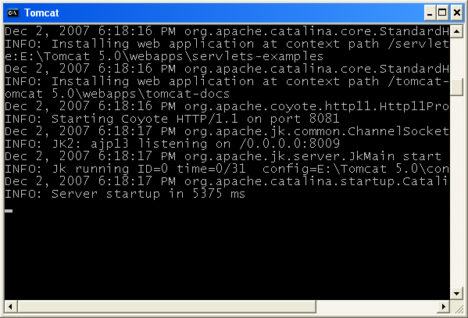

Q) Develop and deploy a web application in which an end user should be able to enter his/her name into a web form. A servlet has to receive the user name, build a dynamic greeting message addressing the user with name and send the web page to the web client.

Step 1: - Directory structure creation
greetingapp
WEB-INF
classes
lib

Step 2: - Web resources development.

Source code of the user.html
<HTML>
<BODY BGCOLOR="wheat">
<CENTER>
<FORM ACTION="http://localhost:8080/greetingapp/greet">
NAME <INPUT TYPE="text" NAME="greet">
<INPUT TYPE=submit VALUE="send">
</FORM>
</CENTER>
</BODY>
</HTML>

Servlet source code
import javax.servlet.*;
import javax.servlet.http.*;
import java.io.*;
public class GreetingServlet extends HttpServlet
{
public void doGet(HttpServletRequest request,HttpServletResponse response)
throws ServletException,IOException
{
String name=request.getParameter("greet");
String message="HELLO! "+name;
response.setContentType("text/html");
PrintWriter outstream=response.getWriter();
outstream.println("<HTML>");
outstream.println("<BODY BGCOLOR=cyan>");
outstream.println("<H3> "+message+ "</H3>");
outstream.println("</BODY>");
outstream.println("</HTML>");
outstream.close();
}
}

Step 3: - Deployment Descriptor (web.xml)
<web-app>
<servlet>
<servlet-name>greeting</servlet-name>
<servlet-class>GreetingServlet</servlet-class>
</servlet>
<servlet-mapping>
<servlet-name>greeting</servlet-name>
<url-pattern>/greet</url-pattern>
</servlet-mapping>
</web-app>
Step 4: - configuring the resources.
greetingapp
user.html
WEB-INF
web.xml
classes
GreetingServlet.class
In order to deploy the web application, copy the root directory along with all the resources and helper files into the “webapps” directory of Tomcat installation directory and start the Tomcat.
Launch the browser and type the following URL.
http://localhost:8080/greetingapp/user.html
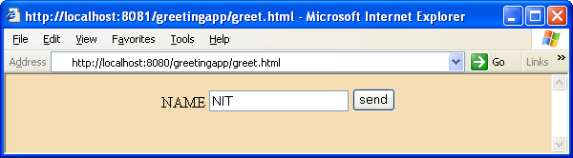
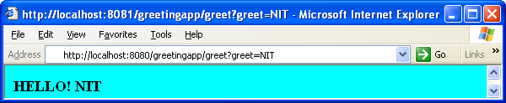
Q) Web application in which end-user should be able to enter 2 numbers into the web form. If add button is clicked, servlet should send the sum of two numbers to the client. If the subtract button is clicked the difference should be sent to the client.

Directory structure along with files
computeapp
numbers.html
WEB-INF
web.xml
classes
ComputeServlet.class
After deployment we have to type the following URL in the browser.
http://localhost:8080/computeapp/numbers.html

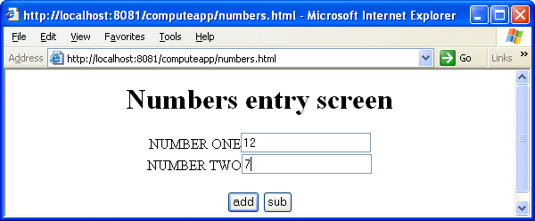
If the end user clicks on “sub” button, the following result appears.
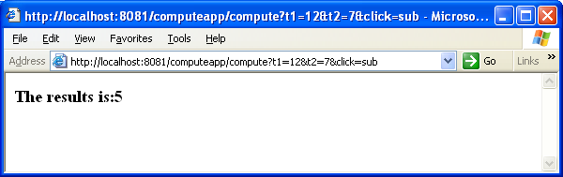
If the clicked button is “add” the result is as follows.
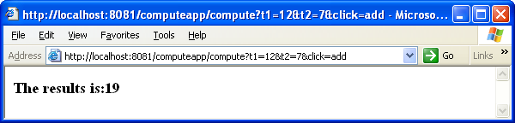
numbers.html
<HTML>
<BODY >
<CENTER>
<H1>Numbers entry screen</H1>
<FORM ACTION="http://localhost:8080/computeapp/compute">
NUMBER ONE<INPUT TYPE="text" NAME="t1"><BR>
NUMBER TWO<INPUT TYPE="text" NAME="t2"><BR><BR>
<INPUT TYPE="submit" NAME="click" VALUE="add">
<INPUT TYPE="submit" NAME="click" VALUE="sub">
</FORM>
</CENTER>
</BODY>
</HTML>

ComputeServlet.java
import javax.servlet.*;
import javax.servlet.http.*;
import java.io.*;
public class ComputeServlet extends HttpServlet
{
public void doGet(HttpServletRequest request,
HttpServletResponse response) throws ServletException,IOException
{
int n1=Integer.parseInt(request.getParameter("t1"));
int n2=Integer.parseInt(request.getParameter("t2"));
int result=0;
String submit=request.getParameter("click");
System.out.println(submit);
if(submit.equals("add"))
result=n1+n2;
else
result=n1-n2;
response.setContentType("text/html");
PrintWriter out=response.getWriter();
out.println("<HTML>");
out.println("<BODY >");
out.println("<H3> The results is:"+result+ "</H3>");
out.println("</BODY>");
out.println("</HTML>");
out.close();
}
}
Note: - In this web application we have to give same request parameter name for both the submit buttons. Their captions must be different. In the servlet, we have to call getParameter() on the request object by supplying “submit” button’s request parameter name. It returns the caption of the button, which, the end user clicked.
web.xml
<web-app>
<servlet>
<servlet-name>arithmetic</servlet-name>
<servlet-class>ComputeServlet</servlet-class>
</servlet>
<servlet-mapping>
<servlet-name>arithmetic</servlet-name>
<url-pattern>/compute</url-pattern>
</servlet-mapping>
</web-app>

Application Flow
- End-user enters the URL for the numbers.html in the browser. Web server fetches the web form to the client.
- End-user enters 2 numbers into the web form and clicks on one of the 2 submit buttons.
- Web server receives the client request and dispatches it to the servlet engine.
- Servlet engine picks up the public name of the servlet from the incoming request, looks into the web.xml and dispatches the request to the ComputeServlet.
- In the ComputeServlet, request object is used to capture the form data. I.e. 2 numbers. On which submit button end-user clicked also found, the result is calculated and the response is given to the web server. I.e. to the browser stream. Web server gives the response to the web client.

Performing database operations in servlets
While a servlet is communicating with the databases the following observations are made.
- Driver class, database URL, user name and password don’t hard code in the servlet. Get them from the web.xml as initialization parameters. As a result our servlet code will not change even when the database server, the driver or the authentication information is changed.
- Almost all the times make use of the PreparedStatement object to perform database operations.
- Override zero argument init method. In the init method, establish the database connection and build the PreparedStatement object.
- If the web form is submitted for retrieving data from the database, i.e. if the client request is GET request, override the doGet method in the servlet.
- If the web form is submitted for making changes in the database, i.e. if the client request is POST request, override the doPost method in the servlet.
- Within the doGet or doPost method perform database operations. I.e. executing the PreparedStatement for submitting the SQL statement to the database.
- Close the PreparedStatement and database connection in the destroy method.
- Implement exception handling explicitly in init(), doGet() or doPost() and destroy() methods. ClassNotFoundException and SQLException can’t be added to the throws clause of these methods as it violates method overriding rule.

Supplying Initialization Parameters
In the web.xml the following elements are used to supply initialization parameters to the servlets.
<init-param>
<param-name>driver</param-name>
<param-value>sun.jdbc.odbc.JdbcOdbcDriver</param-value>
</init-param>

During servlet initialization phase the servlet engine encapsulates these name value pairs of strings in the ServletConfig object and passes them to the servlet. Within the servlet we retrieve the initialization parameter value by calling getInitParameter method.
Q) Web application in which end-user enters the employee number into the web form. Servlet sends the employee details in HTML tabular format.

Directory structure
getapp
emp.html
WEB-INF
web.xml
classes
DatabaseServlet.class
After deployment type the URL http://localhost:8080/getapp/emp.html
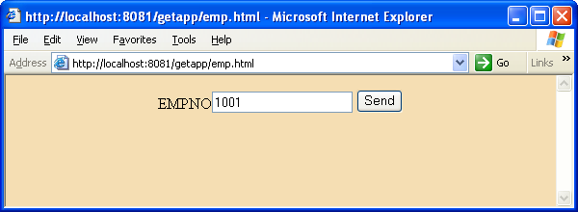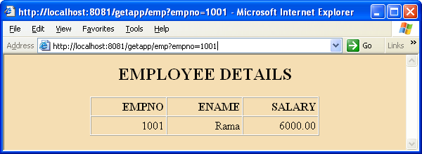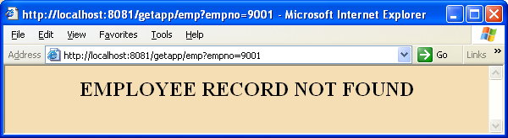

emp.html
<HTML>
<BODY BGCOLOR="wheat">
<CENTER>
<FORM ACTION="./emp">
EMPNO<INPUT TYPE=text NAME="empno">
<INPUT TYPE=submit VALUE="Send">
</FORM>
</CENTER>
</BODY>
</HTML>

DatabaseServlet.java
import java.io.*;
import java.sql.*;
import javax.servlet.*;
import javax.servlet.http.*;
public class DatabaseServlet extends HttpServlet
{
Connection con;
public void init() throws ServletException
{
String d=getInitParameter("driver");
String u=getInitParameter("url");
String us=getInitParameter("user");
String pwd=getInitParameter("pass");
try
{
Class.forName(d);
con=DriverManager.getConnection(u,us,pwd);
System.out.println("Connection is established");

}
catch(ClassNotFoundException e)
{
System.out.println(e);
}
catch(SQLException e)
{
System.out.println("Unable to establish the connection");
}
}//init()
public void doGet(HttpServletRequest request,
HttpServletResponse response)throws ServletException,IOException
{

response.setContentType("text/html");
PrintWriter pw=response.getWriter();
try
{
pw.println("<HTML>");
pw.println("<BODY BGCOLOR=wheat>");
pw.println("<CENTER>");
Statement st=con.createStatement();
ResultSet rs=st.executeQuery("SELECT * FROM
EMPLOYEE WHERE EMPNO="+request.getParameter("empno"));
ResultSetMetaData metadata=rs.getMetaData();
int count=metadata.getColumnCount();
if(rs.next())
{
pw.println("<H2>EMPLOYEE DETAILS</H2>");
pw.println("<TABLE BORDER=1
CELLPADDING=3 CELLSPACING=0>");
pw.println("<TR>");
for(int i=1;i<=count;i++)
pw.println("<TH align=right
width=100>"+metadata.getColumnName(i)+"</TH>");
pw.println("</TR>");
pw.println("<TR>");
for(int i=1;i<=count;i++)
pw.println("<TD align=right
width=100>"+rs.getString(i)+"</TD>");
pw.println("</TR>");
pw.println("</TABLE>");
}//if
else
pw.println("<H2> EMPLOYEE RECORD NOT FOUND</H2>");
pw.println("</CENTER>");
pw.println("</BODY >");
pw.println("</HTML>");
pw.close();
rs.close();
st.close();
}//try
catch(SQLException e)
{
System.out.println(e);
}
}//doGet()
public void destroy()
{

if(con !=null)
{
try {con.close();}
catch(Exception e){}
System.out.println("Connection closed");
}
}
}//class

web.xml
<web-app>
<servlet>
<servlet-name>jdbc</servlet-name>
<servlet-class>DatabaseServlet</servlet-class>
<init-param>
<param-name>driver</param-name>
<param-value>sun.jdbc.odbc.JdbcOdbcDriver</param-value>
</init-param>
<init-param>
<param-name>url</param-name>
<param-value>jdbc:odbc:student</param-value>
</init-param>
<init-param>
<param-name>user</param-name>
<param-value>scott</param-value>
</init-param>
<init-param>
<param-name>pass</param-name>
<param-value>tiger</param-value>
</init-param>
</servlet>
<servlet-mapping>
<servlet-name>jdbc</servlet-name>
<url-pattern>/emp</url-pattern>
</servlet-mapping>
</web-app>
Q) Web application to insert employee details into the database.

Directory structure
Postapp
Emp.html
WEB-INF
Web.xml
Classes
PostServlet.class
After deployment http://localhost:8080/postapp/emp.html is typed into the browser.

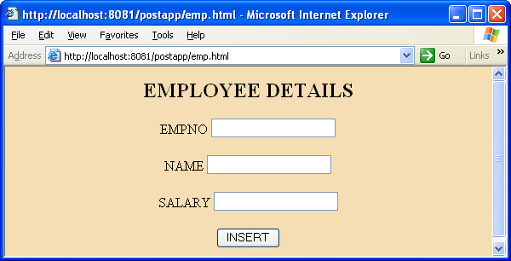

emp.html
<HTML>
<BODY BGCOLOR=WHEAT>
<CENTER>
<H2>EMPLOYEE DETAILS</H2>
<FORM ACTION="./pstmt" METHOD="POST" >
EMPNO <INPUT TYPE=TEXT NAME="empno"><BR><BR>
NAME <INPUT TYPE=TEXT NAME="name"><BR><BR>
SALARY <INPUT TYPE=TEXT NAME="salary"><BR><BR>
<INPUT TYPE="SUBMIT" NAME="click" VALUE="INSERT">
</FORM>
</CENTER>
</BODY>
</HTML>

After the end-user enters the details into the screen and click on the insert button, same screen appears again to continue data entry. From the servlet, the same web form is sent as response. As repetition is involved in database operations, PreparedStatement is used in the servlet to interact with the database.

PostServlet.java
import java.io.*;
import java.sql.*;
import javax.servlet.*;
import javax.servlet.http.*;
public class PostServlet extends HttpServlet
{
Connection con;
PreparedStatement ps;
public void init() throws ServletException
{
String d=getInitParameter("driver");
String u=getInitParameter("url");
String us=getInitParameter("user");
String pwd=getInitParameter("pass");
try
{
Class.forName(d);
con=DriverManager.getConnection(u,us,pwd);
System.out.println("Connection is established");
ps=con.prepareStatement("INSERT INTO EMPLOYEE VALUES(?,?,?)");
}
catch(Exception e)
{
System.out.println(e);
}
}//init()
public void doPost(HttpServletRequest request, HttpServletResponse
response)throws ServletException,IOException
{
int empno=Integer.parseInt(request.getParameter("empno"));
String name=request.getParameter("name");
float salary=Float.parseFloat(request.getParameter("salary"));
response.setContentType("text/html");
PrintWriter out=response.getWriter();
try
{
ps.setInt(1,empno);
ps.setString(2,name);
ps.setFloat(3,salary);
ps.executeUpdate();
RequestDispatcher rd=request.getRequestDispatcher("emp.html");
rd.include(request,response);
}//try
catch(SQLException e)
{
System.out.println(e);
}
}//doPost()
public void destroy()
{
if(ps !=null)
{
try
{
ps.close();
}
catch(Exception e){}
}
if(con !=null)
{
try
{
con.close();
}
catch(Exception e){}
System.out.println("Connection closed");
}
}//destroy
}//class
<web-app>
<servlet>
<servlet-name>insert</servlet-name>
<servlet-class>PostServlet</servlet-class>
<init-param>
<param-name>driver</param-name>
<param-value>oracle.jdbc.driver.OracleDriver</param-value>
</init-param>
<init-param>
<param-name>url</param-name>
<param-value>jdbc:oracle:thin:@localhost:1521:server</param-value>
</init-param>
<init-param>
<param-name>user</param-name>
<param-value>scott</param-value>
</init-param>
<init-param>
<param-name>pass</param-name>
<param-value>tiger</param-value>
</init-param>
</servlet>
<servlet-mapping>
<servlet-name>insert</servlet-name>
<url-pattern>/pstmt</url-pattern>
</servlet-mapping>
</web-app>
Observations to be made.
- In this example, Oracle thin driver is used. We need to copy classes12.jar file into the Tomcat 5.0\common\lib directory.
- RequestDispatcher object is used in order to include emp.html into the servlet response.
- As database information is supplied from the web.xml, we can change the driver & connection string without modifying the servlet source code.
- Even though getInitParameter() is called on the servlet instance in the zero argument init method, internally it is called on the ServletConfig object only.

Important Objects in Servlet Programming
ServletContext:
Servlet engine creates ServletContext object as soon as the web application is deployed. This object is only one per web application. All servlets share this object. ServletContext object is not directly available for servlets. To get its reference we have to call the following method. ServletContext sc=getServletContext();
Even though the above method is called on the servlet instance, internally it is called on the ServletConfig object. I.e. getServletContext method belongs to ServletConfig object.
ServletContext object can be treated as shared informatory repository for application level data. One servlet can store data into this object and another servlet of the same application can access that data. A servlet uses this object for the following purposes.
- To communicate with the web container.
- To talk to other servlets
- To share data (in the form of attributes) with other servlets.
- To get application level initialization parameters known as context parameters.
Whenever a servlet wants to know the web container details in which it is deployed, it can call getServerInfo method on the “sc”(ServletContext) object. To write any information into container log files we call log method on “sc”. One servlet can store a data item into the ServletContext object by calling setAttribute method. Another servlet can get it by calling getAttribute method on the “sc” object. Whenever a servlet wants to communicate with the other servlet, call getRequestDispatcher method on the “sc” object. It produces RequestDispatcher object. Using RequestDispatcher object one servlet can communicate with other servlets of the web application. Initialization parameters are individual for each servlet. They are supplied from web.xml. A servlet retrieves them by calling getInitParameter() on the ServletConfig object. When we want to supply common init parameters for all the servlets we use context parameters.
<context-param>
<param-name>anyname</param-name>
<param-value>anyvalue</param-value>
</context-param>
On the ServletContext we call getInitParameter() to retrieve context parameters.
Q) Web application that explores the usage of ServletContext object.

Directory structure
ServletContextApp
data.html
WEB-INF
web.xml
classes
StorageServlet.class
RetrieveServlet.class
After deploying the web application we type the following URL in the browser.
http://localhost:8080/ServletContextApp/data.html
We get the following screen.
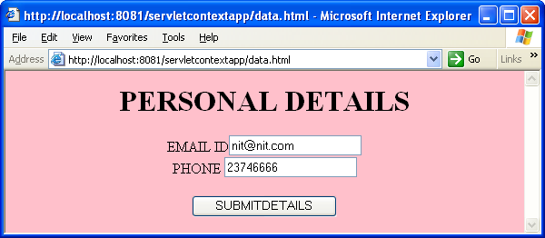
When the end-user enters the details and clicks on the submit button, the SourceServlet retrieves the user data and stores it into the ServletContext object and gives the following response.
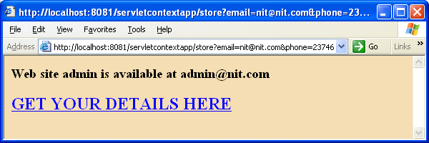
When the end-user clicks on the hyper link, the TargetServlet retrieves data from the ServletContext object and send the same to the client.
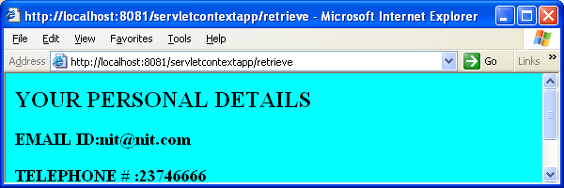

data.html
<HTML>
<BODY BGCOLOR=pink>
<CENTER>
<H1>PERSONAL DETAILS</H1>
<FORM ACTION="./store">
EMAIL ID<INPUT TYPE=text NAME="email"><BR>
PHONE <INPUT TYPE=text NAME="phone"><BR><BR>
<INPUT TYPE=submit VALUE=SUBMITDETAILS>
</FORM>
</CENTER>
</BODY>
</HTML>
web.xml
<web-app>
<context-param>
<param-name>admin </param-name>
<param-value>admin@nit.com</param-value>
</context-param>
<servlet>
<servlet-name>storage</servlet-name>
<servlet-class>StorageServlet</servlet-class>
</servlet>
<servlet>
<servlet-name>retrieval</servlet-name>
<servlet-class>RetrieveServlet</servlet-class>
</servlet>
<servlet-mapping>
<servlet-name>storage</servlet-name>
<url-pattern>/store</url-pattern>
</servlet-mapping>
<servlet-mapping>
<servlet-name>retrieval</servlet-name>
<url-pattern>/retrieve</url-pattern>
</servlet-mapping>
</web-app>

StorageServlet.java
import javax.servlet.*;
import javax.servlet.http.*;
import java.io.*;
public class StorageServlet extends HttpServlet
{
public void doGet(HttpServletRequest request,HttpServletResponse response)
throws IOException,ServletException
{
String email=request.getParameter("email");
String phone=request.getParameter("phone");
response.setContentType("text/html");
PrintWriter pw=response.getWriter();
ServletContext sc=getServletContext();
sc.setAttribute("mail",email);
sc.setAttribute("telephone",phone);
String adminmail=sc.getInitParameter("admin");
pw.println("<HTML>");
pw.println("<BODY BGCOLOR=wheat>");
pw.println("<H3>Websiteadminisavailable at "+adminmail+"</H3>");
pw.println("<H2><AHREF=./retrieve>GET YOUR DETAILS HERE
</A></H2>");
pw.println("</BODY>");
pw.println("</HTML>");
pw.close();
}
}

RetrieveServlet.java

import javax.servlet.*;
import javax.servlet.http.*;
import java.io.*;
public class RetrieveServlet extends HttpServlet
{
public void doGet(HttpServletRequest request,HttpServletResponse response)
throws IOException,ServletException
{
response.setContentType("text/html");
PrintWriter pw=response.getWriter();
ServletContext sc=getServletContext();
String mail=(String)sc.getAttribute("mail");
String phone=(String)sc.getAttribute("telephone");
String adminmail=sc.getInitParameter("admin");
pw.println("<HTML>");
pw.println("<BODY BGCOLOR=cyan>");
pw.println("<H2> YOUR PERSONAL DETAILS</H2>");
pw.println("<H3> EMAIL ID:"+mail+"</H2>");
pw.println("<H3> TELEPHONE # :"+phone+"</H2>");
pw.println("<H3>Web site admin is available at
"+adminmail+"</H3>");
pw.println("</BODY>");
pw.println("</HTML>");
pw.close();
}
}
RequestDispatcher object
RequestDispatcher object is used in the servlets to implement request dispatching. A servlet receives the client request, does the processing partially and hands over the request processing duty to another servlet. This mechanism is known as request dispatching. Inter servlet communication is implemented using RequestDispatcher object. In a servlet we can get RequestDispatcher object reference in two ways.
- RequestDispatcher rd=context.getRequestDispatcher(String absolutepath);
- RequestDispatcher rd=request.getRequestDispatcher(String relativepath);
If we are using the ServletContext object to get the RequestDispatcher, we have to give absolute URL of the target resource. If we are using HttpServletRequest to get the RequestDispatcher object, we give only relative url of the target resource. Request dispatching can be implemented in two ways.
- forward mechanism
- include mechanism
In forward mechanism, a servlet receives the client request, does the preliminary processing and request processing duty is delegated to another servlet/jsp. The target resource is responsible to send the response to the client. To implement forward mechanism the following code has to be written in a servlet.
ServletContext sc=getServletContext();
RequestDispatcher rd=sc.getRequestDispatcher(“/targetservletpublicname”);
rd.forward(request,response);
In include mechanism; the content of a target resource (a Servlet, a jsp, an html file) is included in the current servlet response. In essence, this mechanism enables programmatic server side-includes. In this mechanism the first servlet that receives the client request is responsible to send the response to the client. To implement include mechanism we write the following piece of code in the servlet.
ServletContext sc=getServletContext();
RequestDispatcher rd=sc.getRequestDispatcher(“/targetservletpublicname”);
rd.forward(request,response);
In an object oriented system, objects communicate with message passing. One object gets the reference of the other object and makes a method call (sends a message) on the other object. This is how inter-object communication occurs. In case of servlets, one servlet instance cannot get the reference of other servlet instance. More over, one servlet cannot call the life cycle methods of other servlets. Through RequestDispatcher object such communication is made possible in servlets.

Q) Web application on Request dispatching.

Directory Structure
dispatchapp
emp.html
caption.html
WEB-INF
web.xml
classes
GrossServlet.class
NetServlet.class
In this application end-user enters the basic pay of an employee into the web form and expecting take home salary details. The first servlet knows about allowances and therefore it calculates the gross salary. It forwards the request to the second servlet to deal with deductions. While forwarding, the first servlet stores the gross salary amount in the request object so that the second servlet can retrieve it. It knows about deductions and hence it calculates the take home salary. The second servlet is responsible to send the response to the client. In this servlet, include mechanism also implemented. It includes other html document output in its response. After deployment of the web application we type the following URL in the browser window.
http://localhost:8080/dispatchapp/emp.html
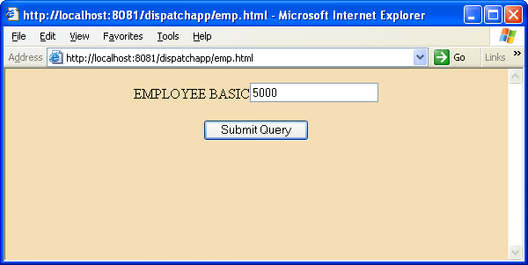

When the end user enters the basic pay and clicks on the submit button, the following response is sent to the client.
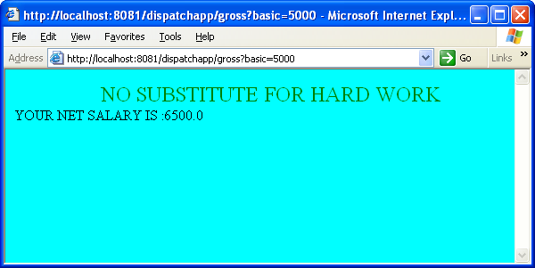
GrossServlet.java
import javax.servlet.*;import javax.servlet.http.*;import java.io.*;
public class GrossServlet extends HttpServlet
{
public void doGet(HttpServletRequest request, HttpServletResponse response)
throws IOException,ServletException
{
float basic=Float.parseFloat(request.getParameter("basic"));
float da=0.5f*basic;
float hra=0.4f*basic;
float gross=basic+da+hra;
Float f=new Float(gross);
request.setAttribute("gross",f);
ServletContext sc=getServletContext();
RequestDispatcher rd=sc.getRequestDispatcher("/net");
rd.forward(request,response);
}
}
NetServlet.java
import javax.servlet.*;import javax.servlet.http.*;import java.io.*;
public class NetServlet extends HttpServlet
{ public void doGet(HttpServletRequest request,HttpServletResponse response)
throws IOException,ServletException
{
response.setContentType("text/html");
PrintWriter out=response.getWriter();
Float gross=(Float)request.getAttribute("gross");
float net=gross.floatValue()-2000-1000;
ServletContext sc=getServletContext();
RequestDispatcher rd=sc.getRequestDispatcher(“/caption.html”);
rd.include(request,response);
out.println("<HTML>"); out.println("<BODY BGCOLOR=cyan>");
out.println("YOUR NET SALARY IS :"+net);
out.println("</BODY>"); out.println("</HTML>");
out.close();
}
}
web.xml
<web-app>
<servlet>
<servlet-name>source</servlet-name>
<servlet-class>GrossServlet</servlet-class>
</servlet>
<servlet>
<servlet-name>target</servlet-name>
<servlet-class>NetServlet</servlet-class>
</servlet>
<servlet-mapping>
<servlet-name>source</servlet-name>
<url-pattern>/gross</url-pattern>
</servlet-mapping>
<servlet-mapping>
<servlet-name>target</servlet-name>
<url-pattern>/net</url-pattern>
</servlet-mapping>
</web-app>
caption.html
<HTML>
<BODY>
<MARQUEE><FONT size=5 color=green>NO SUBSTITUTE FOR HARD WORK</FONT></MARQUEE>
</BODY>
</HTML>
Applying filters to servlets

A filter is a container-managed object that is declaratively inserted within the request-response cycle of http client and http server. A filter instance acts as an interceptor. It is a preprocessor of the request before it reaches a servlet and a post processor of the response leaving the servlet. A filter can perform the following.
- Intercept a servlet’s invocation before a servlet is called.
- Examine the request before a servlet is called.
- Modify the request headers and request data.
- Modify the response headers and response data.
- Intercept a servlet’s invocation after the servlet is called.
A filter object implements javax.servlet.Filter interface. The interface provides 3 life cycle methods.
public void init(FilterConfig): - Servlet engine calls this method only once after instantiating the filter. Initialization parameters are encapsulated in the FilterConfig object. By calling getInitParameter method in the FilterConfig object we can retrieve them.This method must complete successfully before the filter is asked to do any filtering work.
public void doFilter(ServletRequest,ServletResponse,FilterChain): - It is called by the container each time a request/response pair is passed through the chain due to a client request for a resource at the end of the chain. The FilterChain passed into this method allows the filter to pass on the request and response to the next entity in the chain.
public void destroy(): - Called by the servlet engine to indicate to a filter that it is being taken out of service. This method gives the filter an opportunity to clean up any resources that are being held. For example, closing of the database connection.

Q) Web application in which, filters are applied to a servlet.
In this example, two filters are applied to a servlet. Applying more than one filter to a web resource is known as filter chaining. The first filter authenticates the user before the request is forwarded to the servlet. If authentication fails the filter itself sends the error page to the client. If the user name and password are correct, the first filter switches the control to the next filter. In this filter, the number of times the request came to the servlet is captured ad the information is written to the container log files.

Directory structure
filterchainingapp
login.html
error.html
WEB-INF
web.xml
classes
AuthenticationFilter.class
HitCounterFilter.class
WelcomeServlet.class
http://localhost:8080/filterchainingapp/login.html
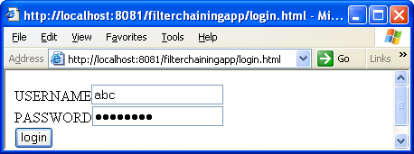
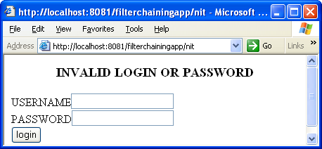
login.html
<HTML>
<BODY>
<FORM action="./nit" METHOD="POST">
USERNAME<input type=text name=user><br>
PASSWORD<input type=password name=password><br>
<input type=submit value=login>
</FORM>
</BODY>
</HTML>
error.html
<HTML>
<BODY>
<CENTER><H3>INVALID LOGIN OR PASSWORD</H3></CENTER>
<FORM action="./nit" METHOD=POST>
USERNAME<input type=text name=user><br>
PASSWORD<input type=password name=password><br>
<input type=submit value=login>
</FORM>
</BODY>
</HTML>

WelcomeServlet.java
import javax.servlet.*;import javax.servlet.http.*;
import java.io.*;
public class WelcomeServlet extends HttpServlet
{
public void doPost(HttpServletRequest request,HttpServletResponse response)
throws IOException,ServletException
{
response.setContentType("text/html");
PrintWriter pw=response.getWriter();
pw.println("WELCOME TO OUR WEBSITE");
pw.close();
}
}

AuthenticationFilter.java
import javax.servlet.*;import java.io.*;import java.sql.*;
public class AuthenticationFilter implements Filter
{
ServletContext sc;
Connection con;
public void init(FilterConfig f) throws ServletException
{
System.out.println("Filter initailized");
String d=f.getInitParameter("driver");
String url=f.getInitParameter("url");
String usr=f.getInitParameter("user");
String pwd=f.getInitParameter("pass");
try
{
Class.forName(d);
con=DriverManager.getConnection(url,usr,pwd);
System.out.println("connection established");
}
catch(Exception e)
{
e.printStackTrace();
}
sc=f.getServletContext();
}
public void doFilter(ServletRequest request, ServletResponse
response, FilterChain chain)
throws IOException,ServletException
{
Statement st=null;
ResultSet rs=null;
String user=request.getParameter("user");
String pwd=request.getParameter("password");
try
{
st=con.createStatement();
String sql="SELECT * FROM OURUSERS WHERE usr='"+user+"' and
password='"+pwd+"'";
rs=st.executeQuery(sql);
if(rs.next())
chain.doFilter(request,response);
else
sc.getRequestDispatcher("/error.html").forward(request,response);
}
catch(Exception e)
{
e.printStackTrace();
}
finally
{
try
{
if(rs !=null)
rs.close();
if(st !=null)
st.close();
}
catch(Exception e) { e.printStackTrace(); }
}
}
public void destroy()
{
try
{
if(con !=null)
con.close();
}
catch(Exception e) { e.printStackTrace(); }
}
}

HitCounterFilter.java
import javax.servlet.*;
import java.io.*;
public class HitCounterFilter implements Filter
{
ServletContext sc;
int count;
public void init(FilterConfig f) throws ServletException
{
sc=f.getServletContext();
}
public void doFilter(ServletRequest request,ServletResponse
response,FilterChain chain)
throws IOException,ServletException
{
chain.doFilter(request,response);
count++;
sc.log("Number of times request came to LoginServlet is "+count);
}
public void destroy(){}
}

web.xml

<web-app>
<filter>
<filter-name>auth</filter-name>
<filter-class>AuthenticationFilter</filter-class>
<init-param>
<param-name>driver</param-name>
<param-value>oracle.jdbc.driver.OracleDriver</param-value>
</init-param>
<init-param>
<param-name>url</param-name>
<param-value>jdbc:oracle:thin:@localhost:1521:server</param-value>
</init-param>
<init-param>
<param-name>user</param-name>
<param-value>scott</param-value>
</init-param>
<init-param>
<param-name>pass</param-name>
<param-value>tiger</param-value>
</init-param>
</filter>
<filter>
<filter-name>hitcount</filter-name>
<filter-class>HitCounterFilter</filter-class>
</filter>
<filter-mapping>
<filter-name>auth</filter-name>
<url-pattern>/nit</url-pattern>
</filter-mapping>
<filter-mapping>
<filter-name>hitcount</filter-name>
<url-pattern>/nit</url-pattern>
</filter-mapping>
<servlet>
<servlet-name>Login</servlet-name>
<servlet-class>WelcomeServlet</servlet-class>
</servlet>
<servlet-mapping>
<servlet-name>Login</servlet-name>
<url-pattern>/nit</url-pattern>
</servlet-mapping>
</web-app>
Session Tracking
Http is a stateless protocol. A web client opens a connection with the http server and requests some resource. The server responds with the requested resource and closes the connection with client. After closing the connection, the http server does not remember any information about the client. The server considers the next request from the same client as a fresh request, with no relation to the previous request. This is what the stateless nature of the Http protocol.
In enterprise web application it is mandatory that client and its associated data must be tracked at server side across multiple requests. There are four approaches to achieve this.
- Hidden from fields
- Cookies
- Session tracking with SERVLE API
- URL rewriting
Note: For Hidden form fields mechanism there is no SERVLET API support available.
Hidden form fields: - A hidden field is similar to an ordinary input field in HTML. The only difference is that the hidden field doesn’t have an associated user-interface element. When the form that contains these hidden fields is submitted, the values of these fields are sent with the request. On the server side, these values are received as request parameters. This mechanism works only when form is submitted, not when you click the hyperlink. The key point is that client selected data travels invisibly from client to server and server to client in this mechanism. That is how state is managed across multiple requests. In J2EE environment this mechanism is not so widely used, as there is no SERVLETS API support available.
Cookies Mechanism
This is a widely used mechanism for both state management and session management. A cookie is a simple place of information stored on the client, on behalf of the server. This information is returned to the server with every request, in addition to the requested document, if may choose to return some state information to the browser. This information includes a URL range within which the information should be returned to the server. The URL range comprises the domain name and some path within the domain. Whenever the browser requests a resource. It cheeks the URL against the URL range of all available cookies. If a match is found, the cookie is also returned with the request. This helps the server overcome the stateless nature of the Http protocol.
Using the cookie mechanism in a Servlet involves the following steps.
Step1: - creating the instance of javax.Servlet.http.Cookie class.
Cookie c=new Cooke (“user”, “rama”);
Step 2: - Making the cookie persistent
c.setMaxAge (3600);
Step 3: - Writing the cookie to the response header.
response.addCookei(c);
Step 4: To retrieve the cookie we call the following method.
Cookie c[] = request.getCookies();
List of important methods in cookie class:
- public String getName():- Returns the name of the cookie.
- public String getvalue():- Returns the value of the cookie.
- public void setMaxAge(int expiry):- Sets the maximum age of the cookie in seconds. A positive value indicates that the cookie will expire after that many seconds have passed, note that the value is the maximum age when the cookie will expire, not the cookie’s current age. A negative value means that the cookie is not stored persistently and will be deleted when the web browser exits. A zero value causes the cookie to be deleted.
- public void setDomain(String pattern):- Specifies the domain within which this cookies should be presented. By default, cookies are only returned to the server that sent them.

Q) Web Application cookies implementation
Directory Structure
Cookieapp
Cookieexample.html
WEB-INF
web.xml
classes
CreateCookie.class
CheckCookie.class
After the web application is deployed, the following URL has to be typed into browser.

http://localhost: 8080/cookieapp/cookieexample.html

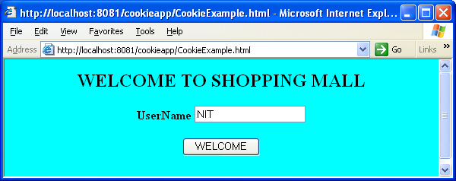
When the end-user enters the name and clicks on the button, the first servlet retrieves the name, convert it into a cookie, and send to the client.When the end-user clicks on the hyper link ,the cookie is sent to the web server again.
Cookieexample.html
<HTML>
<BODY BGCOLOR="cyan">
<CENTER>
<H2> WELCOME TO SHOPPING MALL </H2>
<FORM ACTION="./create" METHOD="post">
<B>UserName</B> <INPUT TYPE=text NAME="user"><br><br>
<INPUT TYPE="submit" VALUE="WELCOME"><br><br>
</FORM>
</CENTER>
</BODY>
</HTML>
CreateCookie.java
import java.io.*;
import javax.servlet.*;
import javax.servlet.http.*;
public class CreateCookie extends HttpServlet
{
public void doPost(HttpServletRequest req,HttpServletResponse res)
throws ServletException,IOException
{
String name=req.getParameter("user");
res.setContentType("text/html");
PrintWriter pw=res.getWriter();
Cookie c=new Cookie("user",name);
res.addCookie(c);
pw.println("<HTML>");
pw.println(" <BODY BGCOLOR=wheat><CENTER>");
pw.println("<H2><A HREF=./check>SHOPPING GOES HERE</A></H2>");
pw.println("</CENTER></BODY><HTML>");
pw.close();
}
}
CheckCookie.java
import java.io.*;
import javax.servlet.*;
import javax.servlet.http.*;
public class CheckCookie extends HttpServlet
{
public void doGet(HttpServletRequest req, HttpServletResponse res)
ServletException,IOException
{
res.setContentType("text/html");
PrintWriter pw=res.getWriter();
Cookie c[]=req.getCookies();
pw.println("<HTML><BODY BGCOLOR=wheat><H2>");
pw.println(" Hai "+c[0].getValue()+" ! hope enjoying
shopping here </H2>");
pw.println(“</BODY>”);
pw.println(“</HTML>”);
pw.close();
}//method
}//class
web.xml
<web-app>
<servlet>
<servlet-name>create</servlet-name>
<servlet-class>CreateCookie</servlet-class>
</servlet>
<servlet>
<servlet-name>check</servlet-name>
<servlet-class>CheckCookie</servlet-class>
</servlet>
<servlet-mapping>
<servlet-name>create</servlet-name>
<url-pattern>/create</url-pattern>
</servlet-mapping>
<servlet-mapping>
<servlet-name>check</servlet-name>
<url-pattern>/check</url-pattern>
</servlet-mapping>
</web-app>
Session Tracking using HttpSession

Session tracking is the ability of the web container to recognize a client uniquely in a series of interactions and also able to associate each request with a particular client. HttpSession object represents the association. The web container maintains this object for the duration of the client session or a configurable time period. Since many clients interact with the container, the container maintains individual HttpSession objects for each client. By using HttpSession object methods we can associate the client state also with the session object. We create the HttpSession object as follows.
HttpSession s=request.getSession();
The above method returns the reference to the container created object that implements the HttpSession interface. If there is no session associated with the current request, the above method creates one. If already a session is associated with the client, it gives the reference to the existing session object.

Important methods of HttpSession
Methods for session lifetime: -
- public long getCreationTime(): - Returns the time that the session was created, in milliseconds since Jan 1, 1970 00.00 hrs.
- public String getId(): - Returns a String containing a unique identifier assigned to this session.
- Public long getLastAccessedTime(): - Returns the time that the session was last accessed by the client, in milliseconds since Jan 1, 1970 00.00 hrs. This method is used to determine the period of inactivity between two consecutive client requests.
- public int getMaxInactiveInterval(): - Returns the length of the time in seconds that the session will remain active between requests before expiring.
- public void setMaxInactiveInterval(int seconds): - This method sets the length of time in seconds that the session will remain active between requests before expiring. The web container makes sure that the session is automatically invalidated after expiry of this interval.
- public Boolean isNew(): - Returns true if the client does not yet know about the session. A client is considered to join a session when it returns session tracking information previously sent by the server.
- public void invalidate():- invalidates the session and unbinds any data associated with it.

Methods for session associating state with session: -
- public void setAttribute(String name,Object value): - stores a value in the session object with some name.
- public void getAttribute(String name): - Returns the object bound with the specified name in this session, or null if no object is bound under the name.
- public void removeAttribute(String name): - Removes the object bound to the session.
- public Enumeration getAttributeNames(): - Returns an Enumeration of String objects bound to the session. These strings are names given to the objects bound to the session.
URL rewriting
When we are implementing session tracking using HttpSession, web container implicitly uses cookies mechanism to exchange the session id between the client and the server. If cookies are disabled in the client, session tracking fails. To overcome this problem we make use of URL rewriting. Appending the session id to the URL is known as URL rewriting. In order for this mechanism to work, all the URLs in the page should be encoded using encodeURL() method of the HttpServletResponse. This method encodes the specified URL by including the session id in it, or, if encoding is not needed, returns the URL unchanged. For robust session tracking, all URLs emitted by the servlet should run through this method.
Q) Web application to implement URL rewriting.
Directory structure
rewriteapp
user.html
WEB-INF
web.xml
classes
SourceServlet.class
TargetServlet.class
After deployment of the web application, type the following URL in the browser.
http://localhost:8080/rewriteapp/user.html
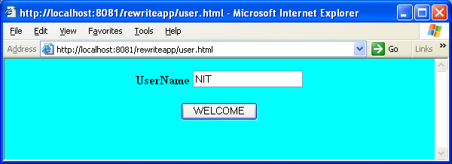
When the end-user clicks on the submit button, the source servlet receives the name and stores it in the session object. It sends a hyperlink to the client as response. If we keep the mouse pointer on the hyper link, we can observe the appended session id in the status bar. This is the effect of URL rewriting. When the end-user clicks on the hyper link, the second servlet receives the request. The container picks up the session id from the request line and gives the existing session object. The servlet retrieves the name from the session object and sends the output to the client.
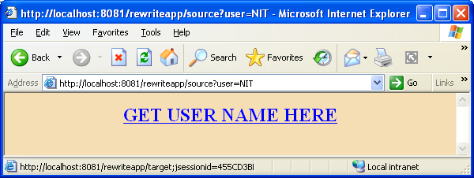

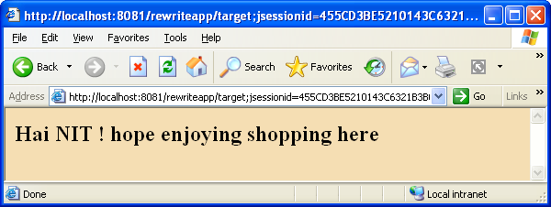

user.html

<HTML>
<BODY BGCOLOR="cyan">
<CENTER>
<FORM ACTION="./source" >
<B>UserName</B> <INPUT TYPE=text NAME="user"><br><br>
<INPUT TYPE="submit" VALUE="WELCOME"><br><br>
</FORM>
</CENTER>
</BODY>
</HTML>

SourceServlet.java
import java.io.*;
import javax.servlet.*;
import javax.servlet.http.*;
public class SourceServlet extends HttpServlet
{
public void doGet(HttpServletRequest req, HttpServletResponse res)
throws ServletException,IOException
{
String name=req.getParameter("user");
res.setContentType("text/html");
PrintWriter pw=res.getWriter();
HttpSession s=req.getSession();
s.setAttribute("usr",name);
pw.println("<HTML>");
pw.println(" <BODY BGCOLOR=wheat><CENTER>");
pw.println("<H2><A HREF="+res.encodeURL("./target")+">GET USER
NAME HERE</A></H2>");
pw.println("</CENTER></BODY><HTML>");
pw.close();
}
}

TargetServlet.java
import java.io.*;
import javax.servlet.*;
import javax.servlet.http.*;
public class TargetServlet extends HttpServlet
{
public void doGet(HttpServletRequest req, HttpServletResponse res)
throws ServletException,IOException
{
res.setContentType("text/html");
PrintWriter pw=res.getWriter();
HttpSession s=req.getSession();
String user=(String)s.getAttribute("usr");
pw.println("<HTML>”
pw.println(“<BODY BGCOLOR=wheat>”);
pw.println(" Hai "+user+" ! hope enjoying shopping here </H2>");
pw.println(“</BODY>”);
pw.println(“</HTML>”);
pw.close();
}
}

web.xml

<web-app>
<servlet>
<servlet-name>one</servlet-name>
<servlet-class>SourceServlet</servlet-class>
</servlet>

<servlet>
<servlet-name>two</servlet-name>
<servlet-class>TargetServlet</servlet-class>
</servlet>

<servlet-mapping>
<servlet-name>one</servlet-name>
<url-pattern>/source</url-pattern>
</servlet-mapping>

<servlet-mapping>
<servlet-name>two</servlet-name>
<url-pattern>/target</url-pattern>
</servlet-mapping>
</web-app>

Event Listeners in Servlets
Listeners are the way to receive notifications when important events occur in a web application. To receive notification of an event, we need to write a class that implements the corresponding listener interface. The servlet engine then calls the appropriate methods of the listener classes when event occurs. Some important Listener interfaces in the SERVLET API are
- ServletContextListener
- ServletContextAttributeListener
- ServletRequestListener
- ServletRequestAtributeListener
- HttpSessionListener
- HttpSessionAttributeListener
ServletContextListener: - This interface allows us to know when a ServletContext is initialized or destroyed. It has 2 methods.
- public void contextDestroyed(ServletContextEvent sce): - This method is called soon after the ServletContext is destroyed. I.e. when the web application is undeployed.
- public void contextInitialized(ServletContextEvent sce): -Servlet engine calls
this method as soon as the ServletContext object is initialized.
ServletContextAttributeListener: - This interface is used to receive notifications about the changes to the attribute list of a ServletContext. It has 3 methods.
- public void attributeAdded(ServletContextAttributeEvent scae): -Servlet engine calls this method as soon an attribute is added to the ServletContext.
- public void attributeRemoved(ServletContextAttributeEvent scae): - It is called when an existing attribute is removed from the ServletContext.
- public void attributeReplaced(ServletContextAttributeEvent scae): -Servlet engine calls this method when an attribute of the ServletContext is replaced.
ServletRequestListener: - Implementations of this interface receive notifications about changes to the servlet request of the web application they are part of. To receive notification events, the implementation class must be configured in the deployment descriptor for the web application. It has 2 methods.
- public void requestDestoryed(ServletRequestEvent sre): - Notification that the servlet request is about to go out of scope.
- public void requestInitialized(ServletRequestEvent sre): - Notification that the servlet request is about to go into scope.

ServletRequestAttributeListener: -Implementations of this interface receives notifications of changes to the attribute list on the servlet request of a web application. To receive notification events, the implementation class must be configured in the deployment descriptor for the web application. It has the following methods.
1. public void attributeAdded(ServletRequestAttributeEvent srae)
Notification that a new attribute was added to the servlet request. Called after the attribute is added.
2. public void attributeRemoved(ServletRequestAttributeEvent srae)
Notification that an existing attribute has been removed from the servlet request. Called after the attribute is removed.
3. public void attributeReplaced(ServletRequestAttributeEvent srae)
Notification that an attribute on the servlet request has been replaced. Called after the attribute is replaced.

HttpSessionListener: - Implementations of this interface are notified of changes to the list of active sessions in a web application. To receive notification events, the implementation class must be configured in the deployment descriptor for the web application. This interface has the following methods.
1. public void sessionCreated(HttpSessionEvent se)
Notification that a session was created.
2. public void sessionDestroyed(HttpSessionEvent se)
Notification that a session is about to be invalidated.
HttpSessionAttributeListener: - This listener interface can be implemented in order to get notifications of changes to the attribute lists of sessions within this web application.
- attributeAdded(HttpSessionBindingEvent se) :- Called after the attribute is added.
- attributeRemoved(HttpSessionBindingEvent se): - Called after the attribute is removed.
- attributeReplaced(HttpSessionBindingEvent se): - Called after the attribute is replaced.

Java Server Pages

JSP is another web technology from Sun Microsystems besides SERVLETS. JSP is a simple but powerful technology used to generate dynamic web pages on the server side. Jsps are direct extension of java servlets and provide a way to separate content generation from content presentation. Important point about jsps is that they are just servlets that are created from a combination of HTML and java code. It means that they have the complete functionality of a normal servlet.
Disadvantages of servlets
Servlets are poor in presenting the response to the client. Dynamic content generation code is mixed with presentation code. As a result development, maintenance and administrative problems arise. RAD(Rapid Application Development) is not promoted as web designing tools cannot be used for web content.
LIFE CYCLE OF A JSP PAGE
When a JSP is accessed for the first time, the server is slower in responding. This is because, every JSP page must be converted into an instance of a Servlet class before it can be used to service client requests. For each request, the JSP engine checks the time stamps of the source JSP page and the corresponding Servlet class file to determine if the JSP Page and the corresponding Servlet class file to determine if the JSP page is new or if it has already been converted into class file. Therefore, if we modify a JSP page, the whole process of converting the JSP page into servlet is performed again. This process consists of the following phases known as life cycle phases.
- Page translation
- Page compilation
- Generated Servlet class loading
- Servlet instantiation phase
- Calling jspInit() known as initialization phase
- Calling _jspService() known as servicing phase.
- Calling jspDestroy() known as destruction phase
Translation phase: - During this phase, the JSP engine reads the JSP page, parses it, and validates the syntax of the tags. Once the validations are completed, the engine creates the java source code that contains public Servlet class.
Compilation phase: - In this phase, the java compilation unit generated in the previous phase is compiled. The result of this compilation is the class file of the container generated Servlet.
Instantiation Phase: - The Servlet class is loaded dynamically and the Servlet engine creates the Servlet instance.
Life cycle methods of ajsp: - Container generated Servlet implements javax.servlet.HttpJspPage which is a sub interface of jspPage interface. JspPage interface extends javx.servlet.servlet interface. JspPage interface declares 2 methods.
- JspInit()
- JspDestroy()
HttpJspPage interface declares one method that serves the Http client requests.
- _jspService()
These methods are known as life cycle methods of a jsp.
Initialization Phase: - The container calls this method to initialize the Servlet instance.
Servicing phase:- In this phase –jspService () method is called by the container every time request comes to the jsp
Destruction phase: - When the container is instructed to take the Servlet instance out of service, before the instance is sent for garbage collection, container calls the life cycle method jspDestroy().

The components of a JSP page
A jsp contains HTML content, jsp tags and java code. By using jsp tags either we can embed java code directly into the jsp page or we can invoke the functionality of java code running behind the scenes. Java code is required for a jsp to provide dynamism to the web page.
Jsp tags can be classified into the following 3 categories.
- Scripting Elements
- Directives
- Actions
Scripting elements: - The basic functionality of scripting elements is to allow jsp authors to embed java code directly into the jsp. We can classify scripting elements as follows.
- Declaration
- Expression
- Scriptlet
Declaration: A JSP declaration lets us define methods or variables in a jsp. These methods and variables become direct members of the container generated Servlet class. We can define both instance and static members in a declaration. A declaration has the following form.
<%!
//Java variable declarations and method definitions
%>
For example,
<%!
private int count=1;//instance variable definition
static int total;//static variable declaration
int getCount() //instance method definition
{
return count;
}
static int getTotal()
{
return total;
}
%>
- In a declaration we can define (rarely) a static block and a class also
- In a jsp we can have any number of declarations in any order.
- Variables declared in a declaration are initialized to java default values.
- Variables in a declaration retain their values across multiple requests because they are created and initialized only once.
Expression: - An expression-scripting element is an embedded java expression that is evaluated and converted to a text string. The resulting text string is placed in a JSP output, in the location at which the element appears. Expressions act as placeholders for java language expressions. An expression is evaluated each time the page is accessed, and its value is then embedded in the output HTML. An expression has the following form.
<%= any valid java expression %>
Examples:
<%= a+b %>
<% = new java.util.Date()%>
- Expressions are inserted into the service method of the container- generated servlet.
- We can have any number of expressions per page.
- Embedded java expression should not be terminated with a semicolon.
- We can print the value of any object or any primitive data type to the output stream using an expression.
- We can also use an expression in a jsp action attribute. In this case the value of the expression does not go to the output stream. It is evaluated at request time, and its value is assigned to the attribute. An expression used in this way is known as request-time attribute expression.
Scriptlet: - A scriptlet is used to include complete fragments of java code in the body of the JSP page. This scripting element differs from the other two in 2 ways.
- It is not limited to the declaration of methods and variables.
- It does not generate a string output directly, as expressions do.
A scriptlet has the following form. <% Any valid free from of java code%>
For example,
<% int sum =0;
for(int I=1;I<10;I++)
sum + =1;
%>
- Scriptlet can be placed anywhere within the jsp body.
- We can place any number of scriptlets in a jsp.
- Each scriptlet is inserted into the service method of the container-generated servlet in the given order.
- The scriptlet is executed each time the page is requested.
- As scriptlets contain any java code, they are typically used for embedding computing logic within a JSP page.

Comments in a JSP page
In a jsp we can have 3 kinds of comments.
- Java comments
- HTML comments
- JSP comments
In a declaration or a scriptlet we can have single line or multi line java comments.
HTML comment is of the form <!-- Any commenting text -->
A JSP comment is of the form <%--Any commenting text --%>
Note: - A JSP comment is also known as a hidden comment as it is not displayed in the client.

Example jsp that makes use of all scripting elements
//one.jsp
<HTML>
<BODY BGCOLOR= “wheat”>
<CENTER>
<H2> FIRST JSP EXAMPLE</H2>
</CENTER>
<%!
String names []={“Rama”, “Rahim”, “David”};// Array definition
private String getName(int index)
{
return names[index];
}
%>
THE THIRD ERSON IS : <% =getName(2) %> <BR>
<%
for(int I=1 ;I<=5;I++){
%>
WELCOME TO JSP WORLD<BR>
<%
}
%>
</BODY>
</HTML>

XML syntax for JSP elements
The JSP specification defines two sets of syntax for authoring JSP pages: standard JSP syntax format and XML syntax format. JSP files that use the standard syntax are called JSP pages. JSP files that use the XML syntax are called JSP documents.
JSP declaration
<jsp:declaration>
int count=0;
</jsp:declaration>

Jsp expression
<jsp:expression>
count
</jsp:expression>

Jsp sriptlet
<jsp:scriptlet>
if(count<6)
count++;
</jsp:scriptlet>

Jsp text
<jsp:text>
Welcome to JSP documents
</jsp:text>
JSP DIRECTIVES
While expressions, scriptlets and declarations are used to define the logic to be executed at run-time (request processing time), directives are used to provide pages with information at translation time-when the JSP page is converted to a Servlet.
Directives are used to specify the classes that are imported, to specify the error page used for catching exceptions, to import tag libraries and making them available to use on the page etc.
JSP directives provide general information about the JSP page to the JSP engine.
JSP directives do not generate code. They are not part of the logic within the JSP code. JSP directives provide directions and instructions to the container, telling it how to handle certain aspects of JSP processing.
There are 3 types of directives according to JSP specification.
- Include directive
- Taglib directive
- Page directive
A JSP directive is of the form
<%@ directive attribute=value %>
include Directive:- An include directive tells the JSP engine to include the contents of another file inline (exactly at the location of directive usage) in the current jsp. Included file can be another jsp or a HTML file. Include directive is of the following form. <%@ include file= “filename” %>
The following example includes the source code of the header.jsp in the current jsp.
<%@ include file= “header.jsp”%>
When the current jsp (the jsp in which this directive is used) receives the client request, the jsp engine reads the entire jsp before translation. Once include directive is encountered, the jsp engine copies the contents of the header.jsp into the current jsp inline. Then it translates the current jsp into a Servlet. As this happens during the translation phase of the jsp, we say that directives are translation time instructions that are given to the jsp container (engine).
taglib Directive: - This directive is used to tell the container which tag library a specific JSP requires. It is also used to assign a prefix that is used within the JSP page to identify tags from a specific tag library. Now jsp engine can locate the code for these tag libraries and get them ready for use by the JSP page. Taglib directive is of the form <%@ taglib prefix= “name” uri= “value”%> (More on this in Custom tags).
page Directive:- This directive informs the engine about the overall properties of a JSP page. This directive applies to the entire translation unit and not just to the page in which it is declared. This directive is of the following form.
<%@ page attribute= “value” attribute = “value”…….%>
Even though there are many attributes for the page directive, the most frequently used ones are discussed here.
import: - This attribute is similar to the import statement in a normal java source code. Once this attribute is used, the jsp container inserts an import statement into the generated Servlet for each of the packages declared using this attribute. We can import multiple packages in a single tag by using a comma-separated list of package names. We can also use multiple tags for readability.
Example:-
<%@ page import= “java.io.*,java.util.*”%>
OR
<%@ page import= “java.io.*,” %>
<%@ page import= “java.util.*”%>
The key point is that it is the only attribute of the page directive that can occur multiple times in a translation unit.
session:- This attribute indicates to the jsp engine whether the current jsp takes part in a Http session. The default value is true. If we don’t want the jsp to participate in a session, then we have to explicitly say
<%@ page session = “false”%>
errorPage: - We can handle the exceptions in a jsp by writing try and catch blocks. However, the JSP specification provides cleaner approach. This approach separates the error handling code from the main page and thus promotes reusability of exception handling mechanism. In this approach, a jsp uses the error page attribute of the page directive to delegate the exception to another JSP page that has the error handling code.
<%@ page erorPage= “handler.jsp”%>
Once the above instruction is encountered, jsp engine delegates the exception handling to handler.jsp if at all an exception is generated in the current jsp.
isErrorpage: - This attribute conveys whether the current jsp can act as an error handler for any other jsp. By default this value is false. In the above example, when we write handler.jsp, in that file we must use the following statement.
<%@ page isErrorPage= “true”%>
contentType: - This attribute specifies the MIME type of the output. The default value is text/html.
If we want to change the MIME type we can say as follows.
<%@ page contentType=”image/gif” %>
JSP IMPLICIT OBJECTS
During the translation phase, the JSP engine declares and initializes nine commonly used variables in the service method of the generated Servlet. They are implicitly made available to a jsp without need of declaring them. These are known as implicit variables or implicit objects. They are as follows.
- request
- response
- session
- config
- application
- page
- exception
- out
- pageContext
request: - This object is of type javax.Servlet.http.HttpServletRequest. It refers to the current request to the jsp. By using this object we can capture the client data.
For example, in a scriptlet we can write as follows.
<%
String name=request.getParameter (“html textbox name”);
%>
with the above scriptlet we can get the form data directly into the jsp.
response: - This object is of type javax.servlet.http.HttpServletResponse. It is used for sending customized response to the client.
session: - This object is of type javax.servlet.http.HttpSession. This object is not available in a jsp if we say <%@ page session= “false” %>. In a Servlet when we implement session tracking we call the method getSession() on the request object. In a jsp it is implicitly available. If we want to implement session tracking in a jsp, we make use of this object.
config: - This object is of type javax.servlet.ServletConfig. When initialization parameters are supplied to the jsp explicitly from the web.xml, we can retrieve them by using this object.
<% String paramvalue= config.getInitParameter (“paramname”); %>
application: - This is an object of type javax.servlet.ServletContext. It refers to the environment to which the jsp belongs. Using this object we can retrieve application level state. All the web components (jsps & servlets) running in the same application can share common information. For example if a Servlet or another jsp has stored some info in the ServletContext object, in our current jsp we can retrieve it as follows.
<% String value= (String) application.getAttribute(“name”); %>
page: - This is an object of type java.lang.object. It refers to the instance of the generated Servlet. This is very rarely used in a jsp.

exception:- This object is of type java.lang.Throwable. This object is not available to all the jsps. Those pages, which are designated as error pages, can access this object.
Note: - Recollect how to declare a page as error handler.
<%@ page isErrorPage= “true” %>
out:- This object is of type javax.servlet.jsp.JspWriter. It refers to the output stream for the page. We use this object to send html content from the jsp. Its usage is seen more in custom actions.
pageContext:- This object is of type javax.servlet.jsp.PageContext. This is the most important implicit object. It refers to the page environment. This object does 3 things.
- It stores references to implicit objects. By supplying this single object to any java helper class, we can supply all the implicit objects. That helper class can retrieve all the implicit by calling getxxx() methods on the pageContext object.
ServletContext context= pageContext.getServletContext();
ServletConfig config=pageContext.getConfig();
HttpSessionsession= pageContext.getSession();
HttpServletRequest request =pageContext.getServletRequest(); etc.
- Provides methods to get and set attributes in different scopes
- Provides methods for dispatching requests to other resources in the web application, which is equivalent to RequestDispatcher in SERVLET API.
pageContext.include(String relativeurl);
pageContext.forward(String relativeurl);
JSP PAGE SCOPES
A scope defines the existence and accessibility of objects from within the jsps and servlets in a web application. All the objects in a jsp page exist in any one of the following four scopes.
- Page
- Request
- Session
- Application
Page scope: - Objects in the page scope are accessible only in the translation unit in which they are defined. They do not exist outside the processing of a single request within a single translation unit. That is, objects in page scope are non shareable across multiple web components. Such objects are stored as attribute-value pairs by the pageContext object. PageContext class provides methods to store objects in page scope and retrieve them.
- public void setAttribute(String name, Object value):- This method is used to store an application level object into the pageContext object with a specified name in page scope.
- Object getAttribute(String name):- Returns the object associated with the name in the page scope or null if not found.
Request scope: - Objects in the request scope are shared across all the web components that process the same request and are accessible only while that request is being serviced. These objects are maintained as name value pairs in the HttpServletRequest object. If we want to store objects in one jsp in request scope, we call the following method on the pageContext object.
setAttribute(String name, Object value, PageContext.REQUEST_SCOPE);
In another jsp, if we want to retrieve the object we call the method on the pageContext object.
Object getAttribute (String name, PageContext. REQUEST_SCOPE);
We have 2 more methods in the PageContext to deal with objects at different scopes
- void removeAttribute(String name, int scope):- Removes the object associated with the specified name in the given scope,
- Enumeration getAttributeNameinScope(int scope)
Application scope: - Application scoped objects are shared across all the web components of the web application. They are accessible for the life of the application. These objects are maintained as name value pairs by the instance of ServletContext. If we want to store an object in application scope, we have to call the following method on the pageContext object.
setAttribute(String name, Object value, pageContext.APPLICATION_SCOPE);
Once the above method call is executed, the specified object reference is stored in the ServletContext object. As ServletContext object is unique for every web application, from any other jsp or servlet in the same web application, the object can be retrieved.
Session scope: - Objects in the session scope are shared across all the requests that belong to a single user session and are accessible only while the session id is valid. These objects are maintained as name value pairs by the instance of HttpSession. If we want to store an object in application scope, we have to call the following method on the pageContext object.
setAttribute(String name, Object value, pageContext.SESSION-SCOPE);
List of scope specifying constants in the pagecontext class
- static final int APPLICATION_SCOPE
- static final int REQUEST_SCOPE
- static final int SESSION_SCOPE
- static final int REQUEST_SCOPE
Methods inherited by the PageContext class from JspContext class
- void setAttribute(string name, Object value, int scope)
- Object getAttribute(String name, int scope)
- Object removeAttribute(String name, int scope)
- Enumeration getAttributeNames InScope(int scope)
Scope search methods of PageContext inherited from JspContext
- Object findAttribute (String name):- This method searches for the named attribute in page, request, session and application in this order and returns the associated value.
- int getAttributeScope (String name):- This method returns the scope in which a given attribute is defined.

JSP ACTIONS (TAGS)
An Action is a request time instruction given to the JSP engine. Actions are high-level JSP elements that create, modify, or use other objects. Actions are coded strictly according to the XML syntax. JSP specification defines two kinds of actions.
- Standard actions
- Custom actions
Standard Actions:- standard actions are those actions that are associated with standard tags. Which are delivered with the JSP container. The container knows the meaning of these tags. Whenever standard action’s tag is encountered in a jsp, the container invokes built in functionally and the required action takes place. Every standard action is of the form
<jsp:action attributed1= “value” attribute2 = “value” />. According to JSP specification the following are the important standard actions.
- include
- forward
- param
- useBean
- setProperty
- getProperty
include standard action:- The net effect of this standard action is equivalent to the RequestDispatcher’s include() method of the SERVLET API. Include standard action is of the form <jsp:include page= “resourcepathtoinclude” />. This standard action includes the output of the target jsp into the response of the main jsp at the time of main jsp is requested. This action works as follows.
When the client makes a request for the main jsp, the JSP container reads the entire page first. When it encounters the include standard action, it inserts a method call inline in the generated Servlet. That method call at runtime combines the response from the target jsp. The container generates servlets for both JSP files.
param standard action:- In the include mechanism or forward mechanism; the included page (target jsp) uses the same request object as the originally requested page (main jsp). As a result, the included page normally sees the same request parameters as that of main jsp. If at all, we want to add or replace those parameters, we make use of param standard action. This action is of the following form. <jsp;param name= “paramname” value= “paramvalue” />
forward standard action:- the net effect of this standard action is equivalent to the RequestDispatcher’s forward() method of the SERVLET API, forward standard action is of the form <jsp:forward page= “resourcepathtoinclude” />. This standard action switches the control completely from the source jsp to the target jsp. And the target jsp is responsible to deliver the output to the client.
USING JAVA BEANS IN A jsp
In order to handle a java bean in a jsp we make use of 3 standard actions.
- useBean
- setProperty
- getProperty
Before we observe the functionality of these standard actions, first of all let us see the details about Java Beans.
A java bean is a specialized java class that is defined according to Java Beans specification. According this specification a bean class should be defined according to the following rules.
- Class is public
- It has public default constructor
- Properties of the class are private
- Each property has one set method and one get method that is public
- The class implements java.io.Serializable interface
Whenever a Java bean is used in a web application, besides the above rules, we have to place it in a user-defined package.
/*
EmployeeBean example
Source code:- EmployeeBean.java
*/
package emppack;
public class EmployeeBean implements java.io.Serializable
{
private int empno;
private float salary;
public void setEmpno(int empno)
{
this.empno=empno;
}
public void setSalary(float salary)
{
this.salary=salary;
}
public int getEmpno()
{
return empno;
}
public float getSalary()
{
return salary;
}
}// EmployeeBean
In order to make use of this bean in a web application, we have to compile it with special command. > javac –d . EmployeeBean.java.
As a result of compilation we get the directory emppack in which EmployeeBean.class file placed. Then copy this emppack in the classes directory of WEB-INF. Now a JSP page in that web application can make use of this bean class.
useBean standard action:- This standard action either gives the existing bean instance reference or creates one. This standard action is of the following form.
<jsp:useBean id= “refname” class = “package.ClassName” scope= “scopename”/>
id attribute:- The id attribute uniquely identifies a particular instance of a bean. This attribute is mandatory because its value is required by other two standard actions. In the generated java Servlet class, the value of id is treated as a java programming Language reference variable. Therefore, this variable name can be used in expressions and scriptlets.
class attribute:- It specifies the java class for the bean instance. If the useBean action tag cannot find an existing bean in the specified scope, it creates a new instance of the bean’s class as specified by the value of the class attribute.
scope attribute:- This attribute specifies the scope in which the bean resides. The existence and accessibility of a java bean from JSP pages are determined by the 4 scopes that we have already discussed. This attribute is optional. If we don’t specify this attribute, by default it takes page scope.
setProperty: - This standard action is used to provide data to the bean instance. This is of the following form
<jsp:setProperty name = “beanref” property= “propertyname” value= “value”/>
name attribute:- This is the bean reference specified in the id attribute of useBean standard action. To which bean instance we are providing data is specified by this attribute.
property attribute: - This attribute specifies to the container that to which bean field data has to be assigned.
value attribute: - This attribute specifies the value to be given to the bean field.
getProperty standard action:- This standard action is used to retrieve values from the bean instance and to send the values to the client. This is of the following form
<jsp:getProperty name= “beanref” peoperty = “propertyname” />
name attribute:- This is the bean reference specified in the id attribute of useBean standard action. Which bean instance’s property we are trying to access is specified by this attribute.
property attribute:- This attribute specifies the bean field name whose value we are trying to access.
CUSTOM ACTIONS (CUSTOM TAGS)
Our own created tags are known as custom tags. By using standard tags we are able to make jsps script less. But the functionally offered by standard actions (tags) is limited. Industry strength web applications demand complex application logic. To meet that requirement and make jsps scriptless we develop custom tags.
JSP API provides library support for custom tag development through the package javax.servlet.jsp.tagext. Whenever we want to develop a custom tag and its associated action, there are 2 important things we need to do.
- Writing the tag handler and copy it into the classes directory
- Write the tag library descriptor and copy it into the WEB-INF
Tag Library descriptor: - It is an xml file with tld extension. In this file we define our own tags, specify their properties and perform mappings between the tags and associated tag handlers.
Tag Handler: - Defining a tag is not sufficient to perform an action. Every tag we define should have a java class associated with it to provide custom functionality. The java class that provides the functionality for the custom tag is known as the tag handler. Every java class cannot act as a tag handler. It should be defined in compliance with the JSP specification. According to the JSP specification, any java class can become a tag handler if it implements javax.servlet.jsp.tagext.Tag interface directly or indirectly. This interface provides life cycle methods for the tag handler. Container manages the life cycle of the tag handler and calls the life cycle methods on the tag handler instance. Tag interface provides the following important life cycle methods.
- setPageContext (pageContext pageContext)
- doStartTag()
- doEndTag()
- release()
setPageContext():- JSP container after instantiating the tag handler, calls this method by supplying the PageContext object as argument. By supplying this object, the container makes the tag handler aware of the environment in which, its associated tag runs. PageContexxt gives us all the implicit objects required in the tag handler.
doStartTag():- Container calls this life cycle method on the tag handler instance when the start tag is encountered in the jsp. We write custom action code in this method. This method can return any of the following 2 constants to the container.
- Tag.SKIP_BODY
- Tag.EVAL_BODY_INCLUDE
The first constant instructs the container to ignore the body of the tag. The second constant indicates to the container that the body of the tag has to be evaluated. doEndTag():- Container calls this method when it encounters end tag in the jsp. This method is called irrespective of whether the custom tag has been written using the full or short hand format. This method can return any of the following 2 constants to the container.
- Tag.SKIP_PAGE
- Tag.EVAL_PAGE
The first constant indicates that the rest of the page after this tag should not be evaluated. The second constant indicates that the rest of the page should be evaluated.
release():- This method is called by the container just before the tag handler instance is garbage collected. This method is used by the programmer to release any resources (data base connections) allocated to the tag handler.
Note:- Our tag handler does not implement Tag interface directly. It extends TagSupport class that implements Tag interface. This provides some default functionality to the tag handler.
APPLICATION FLOW FOR THE CUSTOM TAG
- When JSP engine encounters a custom tag in a JSP page, it checks for a matching prefix in the JSP page’s list of taglib directives.
- When it finds the match, it gets the uri value from the taglib directive.
- Container looks for the uri match in the web.xml
- When match is found in the web.xml, container looks for the taglib-location
- Container uses the TLD file to map the appropriate tag handler with the custom tag.
- Tag handler is executed.

Custom tag with attributes
Whenever a custom tag has attributes the implementation is a 2-step process.
- For every attribute of the tag, one private instance variable plus corresponding public setter method is to be defined in the tag handler class.
- In the .tld file, within the <tag> element we have to make use of <attribute> elements. <attribute> element has 3 child elements.
    - name:- It is used to specify the name of the attribute
    - required:- It specifies whether this attribute is mandatory or optional.
    - Rtexprvalue:- It specifies whether the value can be supplied at runtime or not.
Jsp examples
Q) Web application in which, the end user enters his/her name into the web form. A jsp should receive the name and greet the use with name.
Directory structure
greetingapp
greet.html
greet.jsp
WEB-INF
web.xml
After deployment, type the following URL in the browser.
http://localhost:8080/greetingapp/greet.html
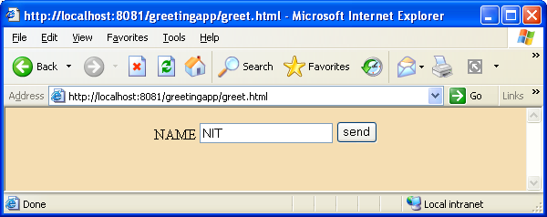
When end user enters name and clicks on the button, the following response comes.
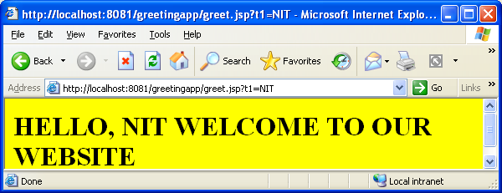
Source code of greet.html
<HTML>
<BODY BGCOLOR="wheat">
<FORM ACTION="greet.jsp">
<CENTER>
NAME <INPUT TYPE="text" NAME="t1">
<INPUT TYPE=submit VALUE="send">
</CENTER>
</FORM>
</BODY>
</HTML>
Source code of greet.jsp
<HTML>
<BODY BGCOLOR="yellow">
<H1> HELLO, <%= request.getParameter("t1") %>
WELCOME TO OUR WEBSITE</H1>
</BODY>
</HTML>
Source code of web.xml
<web-app>
</web-app>
Observation to be made
- We need not register jsps with the web application.
- In the expression, implicit object request is used to capture form data.
- In the <FORM> tag of HTML, ACTION=”greet.jsp” indicates the jsp as the server side entity.

Q) Web application in which, the end user enters 2 numbers into the web form. When clicked on the add button or subtract button, appropriate result should be sent to the client.
Directory structure
computeapp
numbers.html
compute.jsp
WEB-INF
web.xml
After deployment, type the following URL in the browser.
http://localhost:8080/computeapp/numbers.html
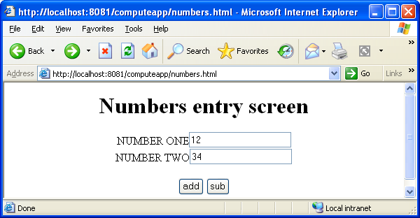
Source code of numbers.html
<HTML>
<BODY >
<CENTER>
<H1>Numbers entry screen</H1>
<FORM ACTION="compute.jsp">
NUMBER ONE<INPUT TYPE="text" NAME="t1"><BR>
NUMBER TWO<INPUT TYPE="text" NAME="t2"><BR><BR>
<INPUT TYPE="submit" NAME="click" VALUE="add">
<INPUT TYPE="submit" NAME="click" VALUE="sub">
</FORM>
</CENTER>
</BODY>
</HTML>
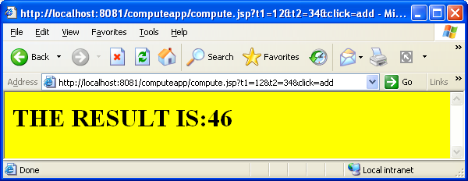
compute.jsp source code
<%
String caption=request.getParameter("click");
int n1=Integer.parseInt(request.getParameter("t1"));
int n2=Integer.parseInt(request.getParameter("t2"));
int result=0;
if(caption.equals("add"))
result=n1+n2;
else
result=n1-n2;
%>
<HTML>
<BODY BGCOLOR="yellow">
<H1> THE RESULT IS:<%= result %></H1>
</BODY>
</HTML>
Source code of web.xml
<web-app>
</web-app>
Observation to be made
- In the HTML document, we need to give same request parameter name for both add and sub buttons. Give different captions.
- In the scriptlet, retrieve the 2 numbers and also the end user clicked button.
Q) Web application in which, a jsp performs database operations.
Directory structure
databaseapp
emp.html
employee.jsp
WEB-INF
web.xml
After deployment, type the following URL in the browser.
http://localhost:8080/databaseapp/emp.html
Source code of emp.html
<HTML>
<BODY BGCOLOR="cyan">
<CENTER>
<H1>Employee Details Query Screen</H1>
<FORM ACTION="employee.jsp">
EMPLOYEE NO<INPUT TYPE="text" NAME="t1"><BR>
<INPUT TYPE="submit" VALUE="send"><BR>
</FORM>
</CENTER>
</BODY>
</HTML>
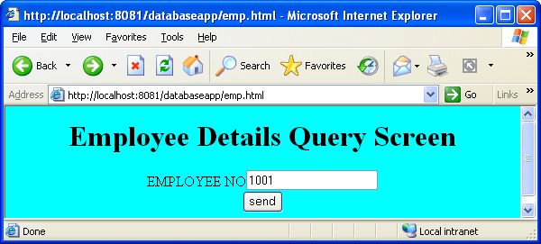
When the end user clicks on the button any one of the following screens come.

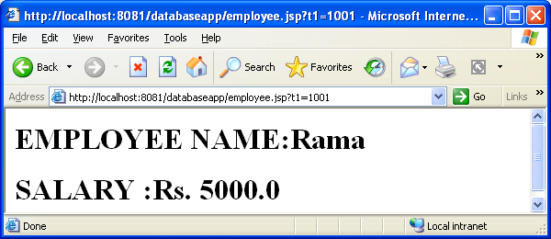

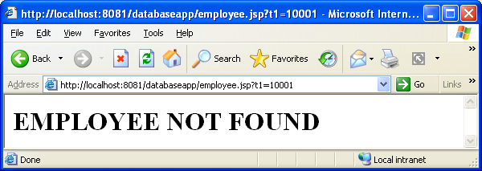

Source code of web.xml
<web-app>
</web-app>
Source code of the employee.jsp
<%@ page import="java.sql.*" %>
<%!
Connection con;
public void jspInit()
{
try
{
Class.forName("sun.jdbc.odbc.JdbcOdbcDriver");
con=DriverManager.getConnection("jdbc:odbc:lnrao","scott","tiger");
}
catch(Exception e)
{
e.printStackTrace();
}
}//jspInit()
public void jspDestroy()
{
try
{
con.close();
}
catch(Exception e){}
}
%>
<%
int eno=Integer.parseInt(request.getParameter("t1"));
String name=null;
float sal=0;
Statement st=con.createStatement();
ResultSet rs=st.executeQuery("SELECT * FROM EMPLOYEE WHERE EMPNO="+eno);
if(rs.next())
{
name=rs.getString(2);
sal=rs.getFloat(3);
%>
<H1> EMPLOYEE NAME:<%= name %></H1>
<H1>SALARY :Rs. <%= sal %></H1>
<%
}
else
{
%>

<H1> EMPLOYEE NOT FOUND</H1>
<%
}
%>
Q) Web application in which a jsp makes use of a Java bean.
JspBeanApp
bookform.html
bookbean.jsp
WEB-INF
web.xml
classes
bookpack
Book.class
After the deployment of the application, type the following URL.
http://localhost:8080/JspBeanApp/bookform.html

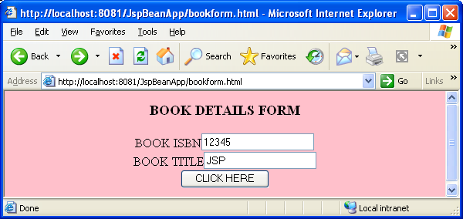
When the end user clicks on the button, the following output is shown
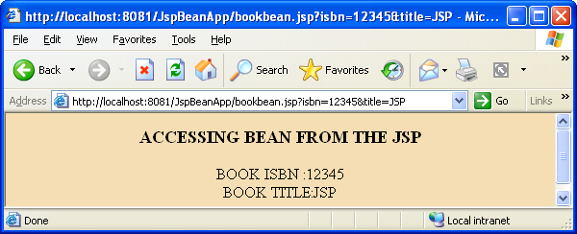
Source code of the bean class
package bookpack;
public class Book
{
private int isbn;
private String title;
public void setIsbn(int isbn)
{
this.isbn=isbn;
}
public int getIsbn()
{
return isbn;
}
public void setTitle(String title)
{
this.title=title;
}
public String getTitle()
{
return title;
}
} //Bean class

jsp source code
<HTML>
<BODY BGCOLOR="WHEAT">
<CENTER>
<H3>ACCESSING BEAN FROM THE JSP</H3>
<%@ page import="bookpack.Book" %>
<jsp:useBean id="book" class="bookpack.Book" scope="request" />
<jsp:setProperty name="book" property="*" />
BOOK ISBN :<jsp:getProperty name="book" property="isbn" /><BR>
BOOK TITLE:<jsp:getProperty name="book" property="title" />
</CENTER>
</BODY >
</HTML>
web.xml source code
<web-app>
</web-app>
Q) Web application in which a java bean is shared in request scope.

RequestScopeApp
emp.html
source.jsp
target.jsp

WEB-INF
web.xml
classes
rscopepack
Employee.class
http://localhost:8080/RequestScopeApp/emp.html
After the web application is deployed, if the above URL is typed in the browser, the following web form is displayed in the web client (browser).
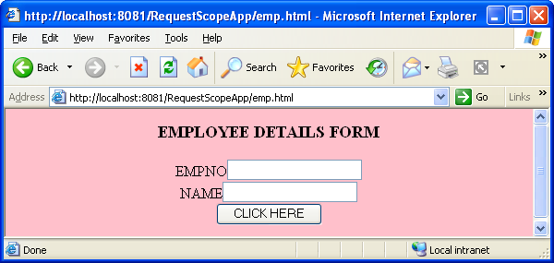 Source code of the emp.html
<HTML>
<BODY BGCOLOR="pink">
<CENTER>
<H3>EMPLOYEE DETAILS FORM</H3>
<FORM ACTION="source.jsp">
EMPNO<INPUT TYPE="TEXT" NAME="empno" ><BR>
NAME<INPUT TYPE="TEXT" NAME="name" ><BR>
<INPUT TYPE="submit" VALUE="CLICK HERE">
</FORM>
</CENTER>
</BODY>
</HTML>
When the end user enters the empno, salary and clicks on the button, it is received by the source.jsp. It instantiates the java bean and populates it. It also keeps the bean in request scope. Now control is switched to the target.jsp using forward standard action. target.jsp retrieves the employee bean state and sends to the client.
source.jsp
<%@ page import="rscopepack.Employee" %>
<jsp:useBean id="emp" class="rscopepack.Employee" scope="request"/>
<jsp:setProperty name="emp" property="*" />
<jsp:forward page="target.jsp" />

target.jsp
<HTML>
<BODY BGCOLOR="WHEAT">
<CENTER>
<%@ page import="rscopepack.Employee" %>
<jsp:useBean id="emp" class="rscopepack.Employee" scope="request"/>
<H3>EMPLOYEE DETAILS</H3>
EMPNO:<jsp:getProperty name="emp" property="empno" /><BR>
NAME:<jsp:getProperty name="emp" property="name" />
</CENTER>
</BODY >
</HTML>
Q) Web application in which a java bean is shared in session scope.
SessionScopeApp
userdetails.html
sessioncontroller.jsp
sessionvalues.jsp
WEB-INF
web.xml
classes
sessionpack
EmailBean.class
http://localhost:8080/SessionScopeApp/userdetails.html
After the web application is deployed, if the above URL is typed in the browser, the following web form is displayed in the web client (browser).
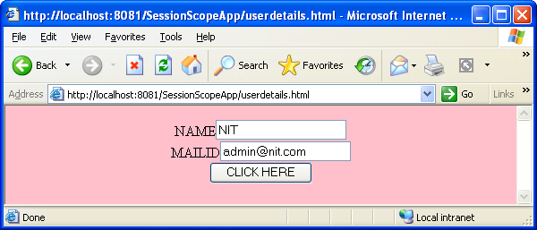
userdetails.html
<HTML>
<BODY BGCOLOR="pink">
<CENTER>
<FORM ACTION="sessioncontroller.jsp">
NAME<INPUT TYPE="TEXT" NAME="username" ><BR>
MAILID<INPUT TYPE="TEXT" NAME="email" ><BR>
<INPUT TYPE="submit" VALUE="CLICK HERE">
</FORM>
</CENTER>
</BODY>
</HTML>

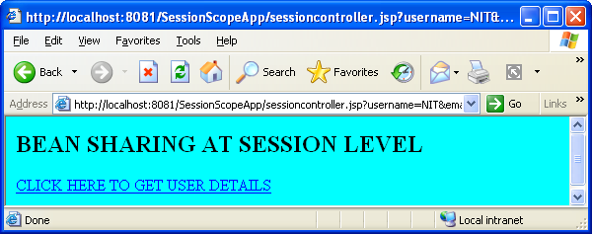

When the end-user clicks on the hyperlink, the following output comes.

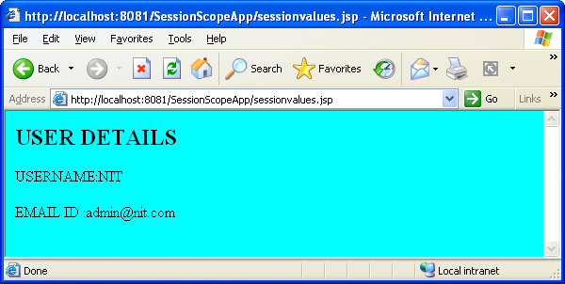
sessioncontroller.jsp
<HTML>
<BODY BGCOLOR="cyan">
<H2>BEAN SHARING AT SESSION LEVEL</H2>
<%@ page import="sessionpack.EmailBean" %>
<jsp:useBean id="mail" class="sessionpack.EmailBean" scope="session" />
<jsp:setProperty name="mail" property="*" />
<A HREF="sessionvalues.jsp">CLICK HERE TO GET USER DETAILS</A>
</BODY>
</HTML>

sessionvalues.jsp
<HTML>
<BODY BGCOLOR="cyan">
<H2>USER DETAILS</H2>
<%@ page import="sessionpack.EmailBean" %>
<jsp:useBean id="mail" class="sessionpack.EmailBean" scope="session" />
USERNAME:<jsp:getProperty name="mail" property="username" /><BR><BR>
EMAIL ID :<jsp:getProperty name="mail" property="email" />
</BODY>
</HTML>

web.xml
<web-app>
</web-app>

Q) Web application that is built using MVC architecture
mvcapp
emp.html
view.jsp
WEB-INF
web.xml
classes
beanpack
Employee.class
nit
servlets
ControllerServlet.class
http://localhost:8080/mvcapp/emp.html

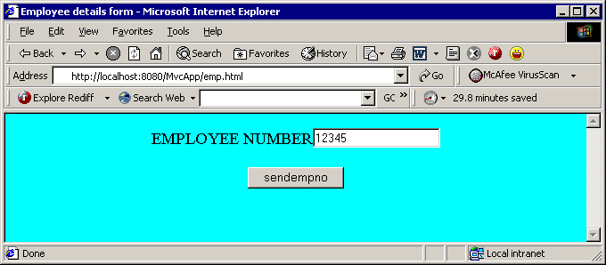

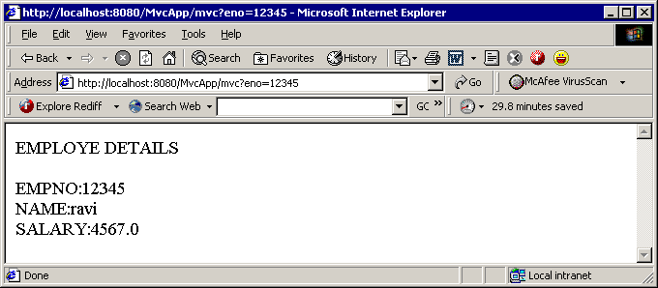

source code of emp.html
<HTML>
<BODY BGCOLOR="cyan">
<FORM ACTION="./mvc">
EMPLOYEE NUMBER<INPUT TYPE="text" NAME="eno"><BR><BR>
<INPUT TYPE=SUBMIT VALUE="SENDEMPNO">
</FORM>
</BODY>
</HTML>
Source code of web.xml
<web-app>
<servlet>
<servlet-name>controller</servlet-name>
<servlet-class>nit.servlets.ControllerServlet</servlet-class>
</servlet>
<servlet-mapping>
<servlet-name>controller</servlet-name>
<url-pattern>/mvc</url-pattern>
</servlet-mapping>
</web-app>
source code of the Java bean
package beanpack;
import java.sql.*;
public class Employee implements java.io.Serializable
{
Connection con;
private int empno;
private String name;
private float salary;
public Employee()
{
try
{
Class.forName("oracle.jdbc.driver.OracleDriver");
con=DriverManager.
getConnection("jdbc:oracle:thin:@localhost:1521:orcl","scott","tiger");
}
catch(Exception e) {}
}
public void setEmpno(int empno)
{
this.empno=empno;
results();
}
public int getEmpno()
{
return this.empno;
}
public void setName(String name)
{
this.name=name;
}
public String getName()
{
return this.name;
}
public void setSalary(float salary)
{
this.salary=salary;
}
public float getSalary()
{
return this.salary;
}
public void results()
{
try
{
Statement s=con.createStatement();
ResultSet rs=s.executeQuery("select * from employee where
empno="+empno);
rs.next();
name=rs.getString("name");
salary=rs.getFloat("salary");
}
catch(Exception e){}
}
}//class
//source code of the controller
package nit.servlets;
import javax.servlet.*;
import javax.servlet.http.*;
import beanpack.Employee;
import java.io.*;
public class ControllerServlet extends HttpServlet
{
public void doGet(HttpServletRequest request,HttpServletResponse response)throws
ServletException,IOException
{
int empno=Integer.parseInt(request.getParameter("eno"));
Employee ebean=new Employee();
ebean.setEmpno(empno);
getServletContext().setAttribute("ebean",ebean);
getServletContext().getRequestDispatcher("/view.jsp").forward(request,respo
nse);
}
}
// source code of the view (view.jsp)
<HTML>
<BODY>
EMPLOYE DETAILS<BR><BR>
<%@ page import="beanpack.Employee" %>
<jsp:useBean id="ebean" class="beanpack.Employee" scope="application" />
EMPNO:<jsp:getProperty name="ebean" property="empno"/><BR>
NAME:<jsp:getProperty name="ebean" property="name"/><BR>
SALARY:<jsp:getProperty name="ebean" property="salary"/>
</BODY>
</HTML>
Q) Web application to implement a custom tag
customtagapp
hello.jsp
WEB-INF
web.xml
tld
ourtaglib.tld
classes
hellopack
HelloHandler.class
http://localhost:8080/customtagapp/hello.jsp
Source code of hello.jsp
<HTML>
<BODY BGCOLOR=WHEAT>
<%@ taglib prefix="nit" uri="http://www.nit.com/customtags" %>
<H3> <nit:hello />WELCOME TO CUSTOM TAGS</H3>
</BODY>
</HTML>
source code of web.xml
<web-app>
<taglib>
<taglib-uri>
http://www.nit.com/customtags
</taglib-uri>
<taglib-location>
/WEB-INF/tld/ourtaglib.tld
</taglib-location>
</taglib>
</web-app>
source code of ourtaglib.tld
<taglib>
<tlib-version>1.0</tlib-version>
<jsp-version>2.0</jsp-version>
<short-name>nit</short-name>
<tag>
<name>hello</name>
<tag-class>hellopack.HelloHandler</tag-class>
<body-content>empty</body-content>
</tag>
</taglib>
Tag handler source code
package hellopack;import javax.servlet.jsp.*;import javax.servlet.jsp.tagext.*;
import java.io.*;
public class HelloHandler extends TagSupport
{
public int doStartTag() throws JspException{
try
{
JspWriter out=pageContext.getOut();
out.println("hello");
}
catch(IOException e){System.out.println(e);}
return SKIP_BODY;
} }
Q) Web application to implement a custom tag with attributes
Tag handler source code
package greetpack;
import javax.servlet.jsp.*;import javax.servlet.jsp.tagext.*;
import java.io.*;
public class GreetingHandler extends TagSupport
{
private String name; private int age;
public void setName(String name)
{
this.name=name;
}
public void setAge(int age)
{
this.age=age;
}
public int doStartTag() throws JspException
{
try
{
spWriter out=pageContext.getOut();
out.println("Hello "+name+" you are "+age+" years old");
}
catch(IOException e){System.out.println(e);}
return SKIP_BODY;
}
}
jsp source code
<HTML>
<BODY BGCOLOR=WHEAT>
<%@ taglib prefix="nit" uri="http://www.nit.com/customtags" %>
<H2><nit:greet name="Ram" age="35" /></H2>
</BODY></HTML>
tld source code
<taglib>
<tlib-version>1.0</tlib-version>
<jsp-version>2.0</jsp-version>
<short-name>nit</short-name>
<tag>
<name>greet</name>
<tag-class>greetpack.GreetingHandler</tag-class>
<body-content>empty</body-content>
<attribute>
<name>name</name>
<required>true</required>
<rtexprvalue>true</rtexprvalue>
</attribute>
<attribute>
<name>age</name>
<required>true</required>
<rtexprvalue>true</rtexprvalue>
</attribute>
</tag>
</taglib>
web.xml source code
<web-app>
<taglib>
<taglib-uri>
http://www.nit.com/customtags
</taglib-uri>
<taglib-location>
/WEB-INF/tld/ourtaglib.tld
</taglib-location>
</taglib>
</web-app>
Q) Web application on IterationTag implementation
iterateapp
loop.jsp
WEB-INF
web.xml
tld
mytaglib.tld
classes
iterationpack
IterationTagHandler.class
After deploying the web application, we have to type the following URL in the browser.
http://localhost:8080/iterateapp/loop.jsp
Tag handler source code
package iterationpack;
import javax.servlet.jsp.*;
import javax.servlet.jsp.tagext.*;
public class IterationTagHandler extends TagSupport
{
private int count;
public void setCount(int count)
{
this.count=count;
}
public int doStartTag() throws JspException
{
if(count>0)
return EVAL_BODY_INCLUDE;
else
return SKIP_BODY;
}
public int doAfterBody() throws JspException
{
if(--count>0)
return EVAL_BODY_AGAIN;
else
return SKIP_BODY;
}
}
jsp source code
<HTML>
<BODY BGCOLOR="pink">
<%@ taglib prefix="nit" uri="customtags" %>
<nit:iterate count="5">THIS IS EVALUATED REPETITIVELY</nit:iterate>
</BODY>
</HTML>
tld source code
<taglib>
<tlib-version>1.0</tlib-version>
<jsp-version>2.0</jsp-version>
<short-name>nit</short-name>
<tag>
<name>iterate</name>
<tag-class>iterationpack.IterationTagHandler</tag-class>
<body-content>JSP</body-content>
<attribute>
<name>count</name>
<required>true</required>
</attribute>
</tag>
</taglib>
web.xml source code
<web-app>
<taglib>
<taglib-uri>
customtags
</taglib-uri>
<taglib-location>/WEB-INF/tld/mytaglib.tld</taglib-location>
</taglib>
</web-app>

When the request comes to the jsp, the body of the tag is evaluated 5 times and the body will be displayed to the client.

TagSupport class implements IterationTag interface. IterationTag interface has one constant and one life cycle method.
IterationTag.EVAL_BODY_AGAIN
int doAfterBody()
After the body of the custom tag is evaluated once, container calls doAfterBody() method. This method can return any one of the following two constants.
- Tag.SKIP_BODY
- IterationTag.EVAL_BODY_AGAIN
As long as the doAfterBody() method returns the EVAL_BODY_AGAIN constant to the container, it evaluates the body of the custom tag and then calls the doAfterBody method. Therefore iteration occurs. Once our requirement of iteration is fulfilled, we return SKIP_BODY constant to the container. Now doAfterBody method is not called. Instead, doEndTag method is called.
APPENDIX-I (HTML Basics)

Hyper Text Markup Language (HTML) is used to develop web pages. We type the HTML source code in notepad, save it with any file name and extension is .html or .htm. Open the browser and load the HTML file into it. Browser executes the HTML instructions and shows the output to the end-user.

Structure of HTML document
<HTML>

<HEAD>

<TITLE> title of the page goes here</TITLE>

</HEAD>

<BODY>

Web page content and instructions as how to present the content

</BODY>

</HTML>

- In the above HTML document we have 4 tags. A tag is an instruction to the browser. Every tag is enclosed in angular brackets in HTML. They are case insensitive. I.e. we can write a tag in Upper case or lower case letters. Forward slash (/) and the tag name indicate that it is the end tag.
- <HTML> is a start tag that indicates to the browser that it is an HTML document. </HTML> is an end tag. It indicates to the browser that it is the end of the HTML document.
- Every HTML document has 2 parts. HEAD part and BODY part. In the Head part we give the title to the web page. It is not the web page content. Between <BODY> and </BODY> whatever we write that is the content of the web page.
- Within the <BODY>, we place the content that we want to show to the end-user and some more tags to instruct the browser how to present that information.
- HTML tags will have attributes to give some more information about the tag to the browser.
- For example, <BODY BGCOLOR=” red”>
- In the above example, BGCOLOR is the attribute. Now the web page is displayed in red color.
- To display headings in the web page, we use <H1> to <H6> tags. <H6> shows the heading in the smallest size.
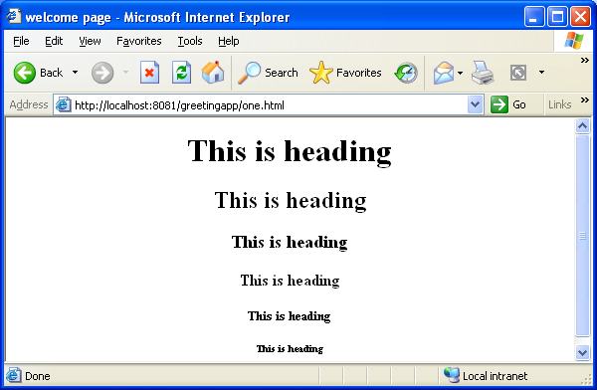

To get the above web page we write the following HTML document whose name is “one.html”

<HTML>
<HEAD>
<TITLE> welcome page </TITLE>
</HEAD>
<BODY>
<CENTER>
<H1>This is heading</H1>
<H2>This is heading</H2>
<H3>This is heading</H3>
<H4>This is heading</H4>
<H5>This is heading</H5>
<H6>This is heading</H6>
</CENTER>
</BODY>
</HTML>

Observations to be made
- <CENTER> tag displays the contents at the center of the web page in the browser.
- The title “welcome page” is displayed at the top of the browser.
- Heading automatically prints the new line. Normal text if we want print in the next line, we have to use <BR> tag.
Creating hyper links
In an HTML document we can create a link to other web pages, servlets OR jsps. Tag to be used is <A>. It has an attribute HREF. Its value indicates the target page.
For example, <A HREF=”two.html”> CLICK HERE </A>
In the above example, In our web page CLICK HERE text is displayed. If we click on that, “two.html” contents are displayed.
//one.html
<HTML>
<BODY>
<A HREF="two.html">CLICK HERE</A>
</BODY>
</HTML>
The following web page is displayed if we load one.html into the browser.
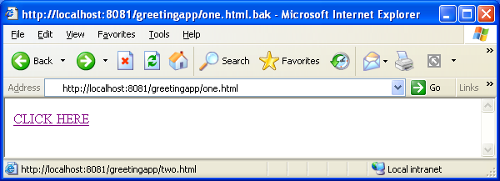

When the end-user clicks on the hyper link, the following output is displayed. I.e. two.html page is displayed.

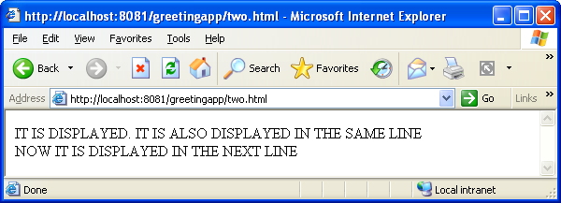
//two.html
<HTML>
<BODY>
IT IS DISPLAYED.
IT IS ALSO DISPLAYED IN THE SAME LINE <BR>
NOW IT IS DISPLAYED IN THE NEXT LINE
</BODY>
</HTML>
Note: - <BR> tag is used to show the contents in the next line.
HTML forms (web forms) creation
Whenever we want to take user input into the web application, we need to present the input screens to the end user. These screens are the front-end for the web applications. A screen is known as a web form. To create a form, we use the <FORM> tag. On the form we place user controls. I.e. buttons, text boxes, password fields, drop down boxes etc. The following HTML creates a login screen.
<HTML>
<BODY BGCOLOR="yellow">
<CENTER>
<H1> Login screen</H1>
<FORM ACTION="servletaddress">
USERNAME<INPUT TYPE="text" NAME="t1"><BR><BR>
PASSWORD<INPUT TYPE="password" NAME="t2"><BR><BR>
<INPUT TYPE=submit VALUE=login>
</FORM>
</CENTER>
</BODY></HTML>
The above HTML document results in the following web page.

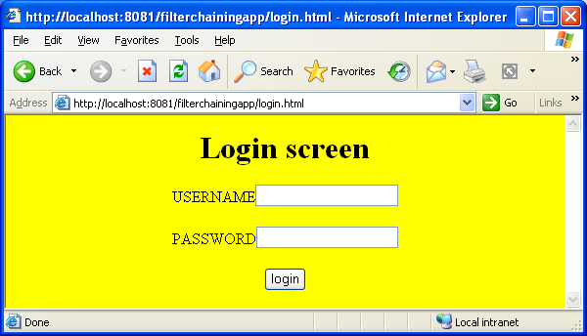

Observations to be made
- <FORM> tag has an attribute ACTION. We give either servlet address or a jsp address as a value to this attribute. When the end-user clicks on the submit button, the specified servlet or jsp receives the form data.
- Labels of the screen need not be created separately.
- To create a text box, password field or a submit button we use the HTML tag <INPUT>. This tag is nested within the <FORM> tag. The kind of control created depends upon its attribute TYPE.
- TYPE=”text” creates the text box. TYPE=”password” creates the password field. TYPE=”submit” creates the submit button.
- Submit button means, if we click on that button, the form is submitted to the web server.
- NAME attribute of the <INPUT> tag is very important. It is known as request parameter name. In the servlet or a jsp we use that name to retrieve the value entered by the user into that HTML control.
- When multiple submit buttons are there, we give names to them in order to find out on which button end user clicked.
- VALUE attribute for the submit button is nothing but its caption.
//emp.html
<HTML>
<BODY BGCOLOR=WHEAT>
<CENTER>
<H2>EMPLOYEE DETAILS</H2>
<FORM ACTION=”jspname" METHOD=”post” >
EMPNO <INPUT TYPE=TEXT NAME="empno"><BR><BR>
NAME <INPUT TYPE=TEXT NAME="name"><BR><BR>
SALARY <INPUT TYPE=TEXT NAME="salary"><BR><BR>
<INPUT TYPE="SUBMIT" NAME="click" VALUE="INSERT">
</FORM>
</CENTER>
</BODY>
</HTML>

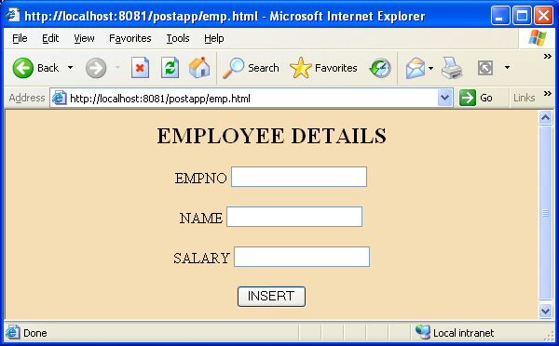
Observations to be made
- <FORM > tag has one more attribute METHOD. It indicates the kind of request we are making to the web server. Generally it has any one of the two values. GET or POST.
- We use post if the form submission affects the database with modifications.

HTML table creation
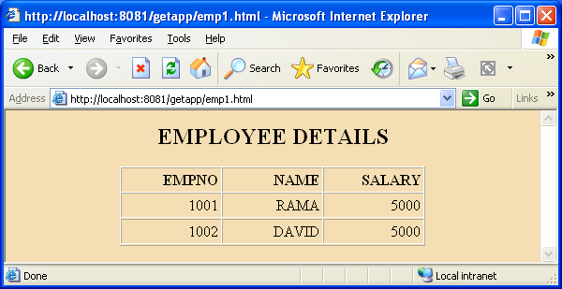
To get the above web page, the following HTML document is required.
<HTML>
<BODY BGCOLOR=wheat>
<CENTER>
<H2>EMPLOYEE DETAILS</H2>
<TABLE BORDER=1 CELLPADDING=3 CELLSPACING=0>
<TR>
<TH align=right width=100>EMPNO</TH>
<TH align=right width=100>NAME</TH>
<TH align=right width=100>SALARY</TH>
</TR>
<TR>
<TD align=right width=100>1001</TD>
<TD align=right width=100>RAMA</TD>
<TD align=right width=100>5000</TD>
<TR>
<TR>
<TD align=right width=100>1002</TD>
<TD align=right width=100>DAVID</TD>
<TD align=right width=100>5000</TD>
<TR>
</TABLE>
</CENTER>
</BODY >
</HTML>

Observations to be made
- To create a table in HTML, we use the <TABLE> tag. CELL PADDING attribute indicates the space between the cell contents and the cell boundary. CELL SPACING attribute indicates the space between each cell. To understand these attributes well it is advised to change their values so many times and see the output.
- To create each row we use <TR> tag.
- As the first row contains column headings, for each column heading we use the tag <TH>. As there are 3 column headings, within the first row we used 3 times <TH>. Here ‘H’ refers to heading.
- Second row and third row are the table data. Therefore, with each <TR> we nested <TD> tag 3 times to fill the table data of 3 columns. Here “D’ refers to data.

